Interactive Flat Panel
Instruction Manual

The final interpretation right of all information in this article belongs to our company.
All unauthorized and permitted copying is not recognized and should be prohibited.
(This document may not fully reflect all the latest changes to the product , the actual product shall prevail)

Disclaimer

When there is one of the following situations , the free warranty
obligation during thewarranty period is not assumed.

Cannot provide valid proof of purchase

Tear oﬀ or damage the disassembly label without permission

Hardware damage caused by improper assembly
Product damage caused by abnormal external force

Product damage caused by exceeding the allowable use environment
Product damage caused by unauthorized modiﬁcation or self-repair

Product damage caused by natural disasters or other force majeure

Violation of the product instruction manual, resulting in product damage

Please check the accessories when you unpack the product
Note: If the product you purchased is a customized model, please conﬁrm whether your conﬁguration meets the requirements when you receive the product .
The customized model is not reﬂected in this manual , and there is a model distinction on the product nameplate .
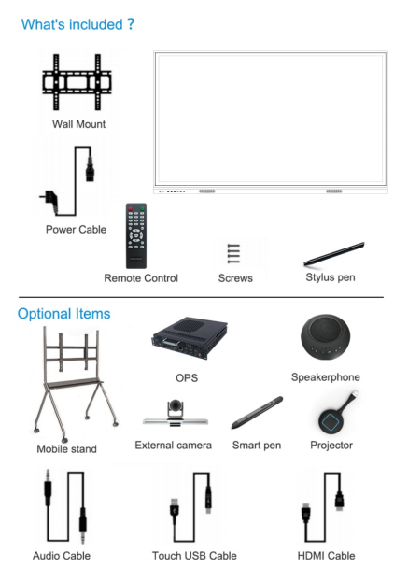

Interactive Flat Panel

Content

Safety and Precautions | 1 | 18.1 Network | 31
The Quick Use Guide | 3 | 18.2 General | 33
Install Wall Mount | 4 | 18.3 Device | 37
Install OPS Computer | 5 | 18.4 Input Channel | 40
Connections and Settings | 6 | 18.5 System | 41
Function Operation | 8 | Simple Troubleshooting | 47
1.Boot wizard | 8 | Maintenance | 48
2.Launcher | 8
3.Sidebar | 10
4.Campass | 13
5.Whiteboard | 13
6.Mini whiteboard | 20
7.Annotation | 21
8.File manager | 23
9.Multi-user | 24
10.Multi-window | 25
11.Welcome page | 27
12.Screen Recording | 27
13.Screen Shot | 28
14.Gallery | 28
15.Voting System | 29
16.Easy Upload | 30
17.Timer | 31
18.System settings | 31

Safety and Precautions

Incorrect use can lead to an electric shock or a ﬁre accident .To prevent dangerous situations , follow the following instructions when installing and cleaning the native machine; to ensure your safety and extend the multimedia interactive all-in-one
service life , read the following safety precautions carefully.

[Place]
Do not place the machine in an unstable and easily inclined position.
Do not place the machine in direct sunlight, near heating objects such as electric heating, or other heat sources and strong light sources.
Do not place the machine near highly radiated equipment.
Do not place the machine where it is wet or dripping.
Do not insert any items into the machine.
Do not place heavy objects on the machine.

[Power Supply]
Check and ensure that the voltage value of the nameplate on the rear shell matches the
main supply voltage value.
Unplug the power cord and antenna plug during a thunderstorm and lightning weather.
Please unplug the power plug when the room is unattended or unused for a long time.
Avoid physical or mechanical damage to the power cord.
Use a special power cord and do not modify and extend the power cord.
Check and make sure the AC power ground is on.

[Screen]
Do not use hard or sharp items instead of a writing pen when writing on the screen.
Unplug the power plug first when cleaning is required.Wipe the screen with a flexible,
dust-free, dry cloth.
Do not clean the machine with water and spray cleaners.
Do not display the high-brightness pictures on the screen for a long time.

[Temperature]
Do not place this machine near an electric heater or radiator.
When the machine is moved from low temperature area to high temperature area, in order to distribute the condensation fully, please place it for a period of time and then power on.
Normal operating temperature of the machine is 5-40 .

[Humidity]
Do not expose the machine to rain, wet or near water.
Please ensure that the room is dry and ventilated.
Normal operating humidity of the machine is: (20%RH-80%RH);
atmospheric pressure: (86kPa-106kPa).
Why does fog often appear on the screen?
In order to ensure the safety of the screen, a layer of tempered glass is added to the outside
of the screen. Meanwhile, there must be a certain gap between the screen panel and tempered glass to guarantee heat dissipation. It is used to reserve air channels for cross-ventilation.
The reason why fog is produced is that there is a temperature difference between the screen temperature and the outside temperature. The hot air meets the lower temperature of the
glass surface to condense and produce water mist. The water mist does not affect normal use. Generally, the mist will slowly evaporate and disappear after a few hours of use.

[Ventilation]
Place the machine in a ventilated place to ensure good heat dissipation.
Ensure the space ventilation around and behind the whole machine and more than 20 cm on the top.
The vents do not cover items such as newspapers, tablecloths, and curtains.
Do not plug any foreign matter into the machine through air vents or openings.There is high voltage inside the machine, inserting a foreign body will cause electric shock or short circuit of internal parts.

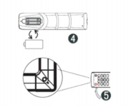
The Quick Use Guide
(1)Verify whether the touch is accurate, use the touch pen to write on the multimedia all-in-one screen, and observe whether the cursor arrow is consistent with the brush, which means
that the touch is stable and can be used normally;
(2)Click on the whiteboard icon to open the smart whiteboard;
(3)To copy the information from the mobile U disk, insert the U disk into the all-in-one USB port, copy and paste, and support double-click to open playback;

【Start-on for use】
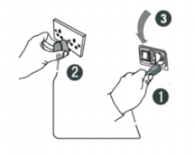

(1) Connect the power cord tail to the power jack on the back of the machine.
(2) 5Connect the power cord plug to the power supply.
(3) Turn on the power switch on the machine and the indicator on the front of the machine is red.
(4) Fit the battery correctly according to the positive and negative battery identification on the
back of the remote control.
(5) Point the remote control at the remote control reception window of the machine, press the
power key of the remote control to turn on, and the indicator shows green.
Note: The built-in computer channel is "built-in computer". For access, use the Input key on the remote control or through the shortcut icon in the suspended ball.

Install Wall Mount

1 . Please install the bracket to the wall or mobile stand according
to the installation guide of the mobile stand or bracket .
Installation Precautions:
When constructing on the wall , the load-bearing safety of the
wall should be considered.

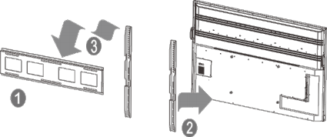
Bracket
Hanger Interactive Flat Panel

3. Please hang the device with the bracket installed on the mobile stand and lock the ﬁxing screws. Please pay attention to
2 . Please refer to the installation guide to install the rack on the machine .
safety during transportation .

【Use the preparation】

Ways of Walls |  | Since the surface of the interactive panel is  tempered glass , it is easy to produce water mist on the glass surface. Please do not place the  machine under an air conditioner. If the water atmosphere is generated , it can be dried for a period of time .

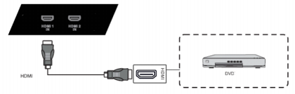
Install OPS Computer

Connections and Settings

1. Install the OPS computer (OPS has been selected at the time of purchase and
has been installed in the factory) OPS compatible: 42MM/30MM thickness;
Interface: 80 PIN international standard OPS interface .
【 Installation Precautions】 :
a . It is strictly forbidden to operate the OPS computer with power on and does not
support hot plugging.
b. Align the OPS computer with the OPS installation slot on the machine ,gently
push it in and insert it completely against the built-in OPS adapter plate .
c . Due to the problem of the interface standard , it is recommended that the
customer use the designated brand and model when upgrading the OPS
conﬁguration .

【Touch output】
Using the VGA or HDMI,USB touch line, connect the external computer and the touch port as shown in the ﬁgure below, and switch the image of the computer to the VGA or HDMI.

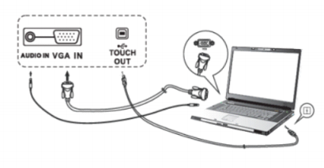
Note: The side Touch port corresponds to the HDMI1, HDMI2 and VGA channels, and the
front Touch corresponds to the front HDMI channel.

【HDM I】
(1) Connect audio and video devices with HDMI output with a HDMI cable; (2) Switch to the corresponding HDMI terminal.

Mobile stand method
In the process of moving and parking the machine, please pay attention .Turn the brake of the mobile frame on or oﬀ .

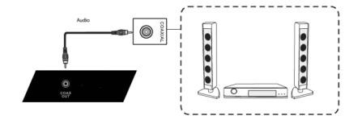
【Coaxial】 Function Operation
(1) Connect audio equipment with coaxial output;
(2) Play the audio.

1.Boot wizard
The boot wizard is a page that pop up when the user turns on for the first time to guide users to quickly get familiar with the basic functions of the *** machine, mainly including the following pages:

【Rs232】
(1) Connect the PC with the RS232 line;
(2) After a successful connection, the central control device can control certain functions
of the machine, such as switching machines.

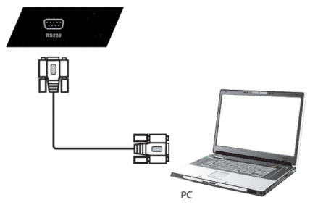

2.Launcher
Launcher is the landing page and theme page after power-up,system defaults to 2 sets of themes, as shown in the figure below:
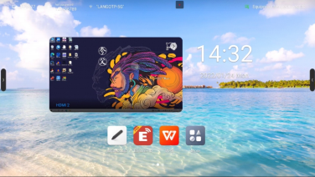
Theme 1

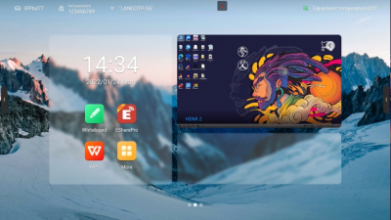
Theme 2
Introduction of page elements:
1) Wallpaper:You can switch theme, custom background, and rotation
wallpaper in system settings--General--Personalization
2) Time: Long press to open the system settings, can set date,time and formats manually
3) Countdown: Long press to open the prompt setting, can set the
countdown, famous sentence content, or hide the prompt
4) Application icon: Click to enter application
5) Source preview: Preview the presetsingal source , like OPS.Click
the selection button at the bottom of the singal source preview
interface to set the source; click the interface section to turn to the
corresponding source page; click the "arrow" in the upper right corner to fold the source preview interface;
Status bar：
The top status bar displays the device name, WiFi-AP name, network
status, device temperature and user exit; described as below:
1) Device name:Display the name of the current device, associated
with hotspot name, screen share device name, Bluetooth name
ect.; users can modify it in the settings- -system setting

2) Hot spot password: Display hotspot password when it is opened;
hotspot can be set in settings- -network- -hotspot
3) Network status: Show the current network and network status
4) Device temperature:Temperature detection, real-time monitoring of the whole machine temperature, users can turn on / off this function in System settings-System-Power state):
When the temperature <65℃ is in the normal temperature range, the text display as green;
When 65℃≤temperature<85℃ the temperature is high, the text display as orange,will remind you to shutdown;
When the temperature≥85℃ the temperature is too high , the text display as red, to protect the device, it will forced shutdown after 5 seconds
5) User exit: Click to exit the current user and enter the user selection page; users can set in the settings- -system- -multi-user;

3.Sidebar
Sidebar are applications on the top of the panel , through which you can operate quickly;
Opening mode: Slide out from the left and right edges to the middle or click the expansion button on the left and right sides to expand the sidebar; 10s without operating in the sidebar will be folded away
automatically .
Sidebar functions : Back, Home , Multitask, Note, Control panel, Signal source
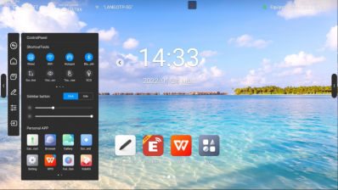

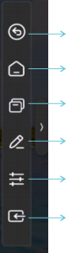
Back: Click it once to return to the previous step of the operation until
back to the home page or the starting position of the operation;
Home:No matter which page you are currently on, click on the home page icon and quickly return to the Android home page.The current application goes back to the background that users can retrieve in multitasking;
Multi-task:Go to the system multitasking page to view and manage the
running applications in the background;
Annotation:Enter the annotation mode, please refer to the "annotation
function"
Control panel:Click the control panel icon to ecpand the display control
panel on the current page.The control panel consists of three modules :
ShortcutTools,“VOL&BRT”, and Application list.
Signal source:Click the signal source icon and the signal source list will
appear(connected source is highlighted),click to enter the corresponding
channel;

ShortcutTools：
(1) Ethernet network:Click to turn on/off Ethernet network
(2) Wireless network:Click to turn on/off Wireless network
(3) WLAN WiFi-AP :Click to turn on/off WLAN WiFi-AP
(4) Timer:Click to turn on/off Timer
(5) Screenshot:Click to open the screenshot , while the sidebar will
automatically hide
(6)Intelligent eye protection: Click to turn on / off, reduce the screen
blue light that damage to your eyes
(7)Touch sense:Click to turn on / off,when turn on, the screen
brightness drops by 30% during touch, and the brightness recovers after 5s without touching to reduce the glare of the brightness during operation or writing
(8)Energy saving:Click to turn on / off,when turn on, the screen
brightness is set to 25 and turned off the auto brightness. If you
adjust the brightness manually or turn on the auto brightness, the
energy saving mode will automatically turn off
(9) Child lock: When opening the child lock, touch screen funcation is
unavaliable,the child lock icon display on the upper left side of the
interface, and the method of unlocking is as follows:

① Use the keyboard and press V-, V-, V+, V+ in turn continuously
② Use the remote control and press V-, V-, V+, V+ in turn continuously ③ Child lock file:
a.New text document
b.Enter U2FsdGVkX18v36IHH2OloQYdlbG+Y18YkDs9R1ACvSE=
c.Name the file usb_child_key
d.Delet the file suffix name.txt
e.The character is UTF-8
f.Saved and place it in the root of U disk
g.Insert the U disk to unlock it in child lock mode
(10) Screen lock:Click to lock screen , the screen unlock mode can be modified in [System Settings]
(11) Channel Setting: under the channel, click to open channel settings to set image scale, VGA image adjustment (under the VGA channel), and HDMI EDID version (under the OPS、HDMI channel)
Quick Setting：
Click the sidebar to expand style setting: When opened , the expansion button displays when the sidebar is folded, you can click the button to expand the sidebar
When off, hide the expansion button when the sidebar is folded , slide
out from the left and right edges to the middle to expand the sidebar Volume control: Slide to control the volume
Brightness adjustment:Slide to adjust the screen brightness, the
brightness can not be adjust manually when in energy-saving mode;
Application list：
To display all the application , click to open application, press the
application with the Apps marked in blue, you can open the application in the small window;
Signal source：
Click the signal source icon and the signal source list will appear( connected source is highlighted),click to enter the corresponding channel;

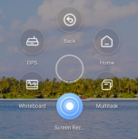
4.Campass
The compass is a shortcut for the users, and the basic operation is
as follows:
Long press the interface with five fingers
to open the compass;
Click the circle middle of the compass to
expand or fold up the compass;
Drag the circle middle of the compass to
move the compass position
The Compass consists of 6 functions modules, among which the
Back, Home, Multitask are the default functions , and the others can
be customized, you can set up common functions depend on your
preference , the specific operations: Setting- -Personalization- -
Compass.
5.Whiteboard

Menu：
The menu contains New, Storage, Sharing, Close, and Settingup ;
basic operations are as follows:

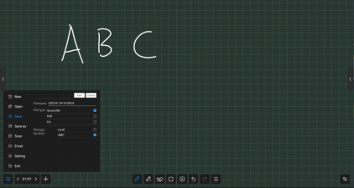

New: Click on “New” to create a new whiteboard,then the current
document is closed;there will a prompt if the current document is not saved;
Open: Enter the File Manager can see all the whiteboard file,click to open the file;there will a prompt if the current document is not saved;
Save: click on "Save" to save the current document,you can customize filename,select storage path and file save format;
Save as: Save the current whiteboard file as another whiteboard file,you can customize filename,select storage path and file save format;
Scan: click on "Scan" in the Menu panel to show the QR code page,user
can downlaod picture and file by scaning QR code;password
settings are optional;support local LAN and external network sharing, users can choose the default mode in the system settings;click on " Encrypt" above the QR code to generate a digit-password, user
need to enter the password to get the content.
Upload to Cloud: Log in to the cloud disk, upload files to oneDrive, Baidu cloud disk and other cloud disks.
Email: Send contents on the current whiteboard by email to a specified user, you need to preset the sender mailbox.
Exit: Click on "Exit" to exit the whiteboard and close the page and process; the user is prompted to save the file if the current document is not
saved.

Setting:
Set the basic state of the whiteboard to make the presentation style
and interact more matching with user expectations;
· Showing time: Click to switch on/off; when turn on, it will show the
time on the screen, on the other hand, it will not show the time on
the screen
. Background setting: Set the default background style when entering
the whiteboard, you can select the background color and gridline style ;
· Email settings:Set up the sender mailbox, which is the sender
mailbox when sending a whiteboard file;
· Taskbar switch: open to dynamically hide the bottom function bar, click popup/hide;
· Threshold: Adjust the sensing threshold of thick and thin pens and erasers
Page Management:
Page management is mainly to manage the pages of each whiteboard, including:
Page up:Click to switch to the previous page of the current page,
not clickable on the first page;
· Page down:Click to switch to the next page of the current page, not clickable on the last page;
Current page: When is shown as 5/8, the preceding number “5”
indicates the current page, and the following number“ 8” indicates the total number of pages;click to view all page thumbnails;you can delete pages or move the page order on the thumbnail;
New page:Click to insert a new page after the current page, and jump to the new page.
. EDIT: Exported pages, removed blank pages

Paintbrush:
There are two kinds of paintbrush: paintbrush 1 with small touching area; paintbrush 2 with comparatively larger touching area, click one to use; Click the paintbrush icon can set the style of paintbrush:

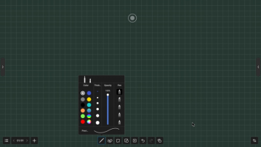

· Color:Preset 9 single colors and 2 gradually changing colors,click to select and effected;brush color can also be customized by the user, click and choose your favorite color;
Thickness :Preset 6 brush sizes,click to select and effected;
Transparency :Paintbrush transparency can be adjusted between 6%-100%;
Paintbrush style:There are three kind of paintbrush style,normal
brush,marker pen and pen,also have two intellgent brush with
function of character recognition and pattern recognition , selecte it then you can convert your handwriting into printed text and pattern;
Erase:
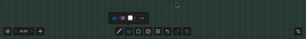
You can erase your handwriting directly with the palm or back of your
hand while writing, the following modes are also supported:
Circle Eraser:Handwriting in the closed-circle can be cleared with just a touch
· Circle to delete:Cross the brush with the object to delete. Strokes that cross or fall within the final circle will be deleted
Slip Clean screen : swipe "Clear Screen" to clear all the handwriting on the current page
Select:
Click on "Select" to switch to the Select mode. click on the handwriting, picture or other elements on the screen to select it, and draw a free
closed shape to select the elements within it.

element can be dragged moved, multi fingers zoom operation
click the selected element
Select the element through which the shape passes

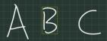
select the element within closed shape

ABC

Shape:
After clicking on, choose to draw graphics, and then drag the brush in
the whiteboard, can draw shapes;
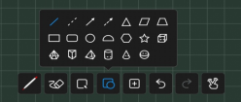
Insert:

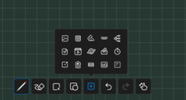
Inserting function supports inserting multiple elements and contents
into the whiteboard,including:
· Picture: Enter the file manager-picture page,click the picture to
insert ; you can select or multiselect (up to 10) pictures then insert
to the whiteboard.

Table :Click the table icon,select number of the table rows and
columns, click OK to insert the table to whiteborad.Use the brush to enter content in the table, table width and height automatically adapt to the brush size; use the selection tool to select the table,and add or delete rows and columns, can also use the brush tool to draw the
horizontal or vertical line in the same row or column through the table to add row or column, similarly, use the brush tool to draw "Z" lines in the same row or column through the table to delete rows or columns;
Document: Click the document insert,then enter the File manager- Document page, you can choose PPT, word, PDF file to insert, in WPS free window mode;
Video:Click the document insert,then enter the File manager-Video page, choose video to insert,in media player free window mode.
Signal source:click to select the signal source that supported by
the device, and the unaccessed sources are in gray and uninsertable;
Browser inserts picture:Click to open the Google or Baidu , enter the keywords then click , long press the picture which you want to add from the search results page,then insert to the whiteboard;
Vote:Used for voting in meeting;
Timer:Used for timing in meeting;
Quick Transfer:Transfer file from mobile to the screen,and insert to the whiteboard;
Mind map: A default three-level mind map can be inserted, sub-levels can be added, and the text box supports writing extensions
Four-line grid: insert English four-line grid, support OCR writing, and can expand the width adaptively
Camera screen: Insert the device camera screen into the whiteboard, you can take pictures of the camera screen and put it into the
whiteboard;
Venues: insert 10 site maps such as badminton courts, basketball courts, football fields, etc.
Insert Ruler: Support inserting four types of rulers, rulers, triangles, and protractors

Undo and Redo:
Undo:Click the Undo button to cancel the most recent step, and
support up to 20 steps
Redo:Click the Redo button to resume the previous undo operation
Single finger/ Multi-finger:
Multi-finger writing :Click to switch on/off;when turn on, open multi-
finger writing mode,can write by 20 people at the same time,when turn off, open single writing mode
Single finger:
Multi-finger：

Split screen writing:
Support split-screen writing: two-split screen/three-split screen/four-split screen
The split-screen interface is a simple whiteboard, retaining the eraser
and brush functions

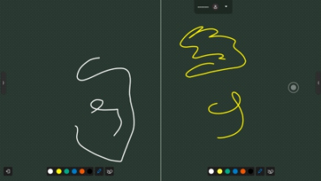
Click Exit in the lower left corner to exit split-screen writing
6.Mini whiteboard
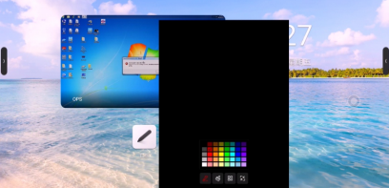
Swiping up from the bottom of any page, can quickly slide out the mini whiteboard and write quickly; basic features include:
· Paint Bursh: You can choose the color and write fast;
Erase :Same as whiteboard erase.
QR code:Click scan code to generate web link QR code, you can use mobile scanning QR code to obtain whiteboard content (picture format);You can open encryption, scan code after entering the
generated password to obtain content
Minimization: Click or multi-fingers slide down to fold up whiteboard;

7.Annotation
Click the Annotation icon on the sidebar or compass to enter the
annotation mode,you can write annotations on the current interface
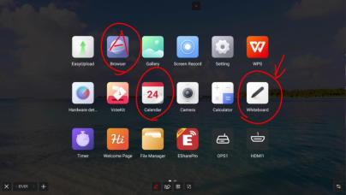
Pen:
The default stroke is red, and you can touch Paintbrush Icon to select
color , opacity and thickness.
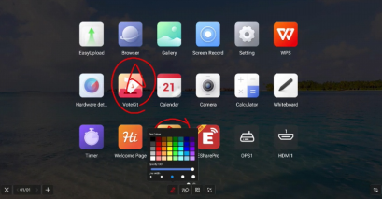

Scan share:
click on "Scan" in the Menu panel to show the QR code page,user can downlaod picture and file by scaning QR code;password settings are optional;support local LAN and external network sharing, users can
choose the default mode in the system settings;click on "Encrypt"
above the QR code to generate a digit-password, user need to enter the password to get the content.

Minimization:
If you need to switch pages or operate on the current page, you can click to temporarily minimize the annotation mode and enter the
annotation mode again through the sidebar or compass
Your previous annotation can be viewed in page management, page management function same as whiteboard refer to 2.5.3 page
management

Close and Save:
Click the left / right lower corner close button, exit the annotation and empty the annotation content. Before you exit, you can choose whether to save all the content, support saving as picture or PDF file

Erase:
Same as whiteboard classic pattern erase

8.File manager
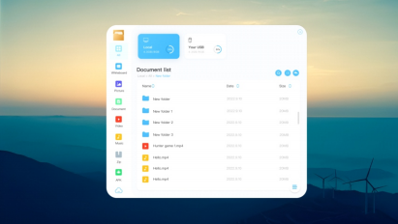

Introduction:
File manager can view files within local and external devices of the
system, providing two forms of viewing
All documents:Open in the folder directory
File type:Search files in the local and U disks by file type, such as whiteboard files, pictures, videos, music, compression packs, etc

Common function:
· The function bar is collapsed by default, click to expand
Open file: find the file you want to open, click to open;
· Select file: Click in the lower right corner of the file list page
to check the file, and support operations such as copying,
cutting, and deleting after selection;

· Create a new folder: Click on the lower left corner of the file
list page to create a new folder;
· File display style: Click the two icons in the upper right corner to switch between tile and list file display styles;
Sorting adjustment:click the name,size, and time at the top of the file list to adjust the sorting according to these factors;
· Search: Click Search 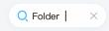 in the upper right
corner to expand the input box, enter keywords to search local file.

9.Multi-user

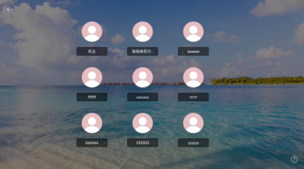
In order to solve the multi-purpose scenario of IFPD, the multi-user function is proposed；
Multiple users have three permissions: primary user, common user, and visitor. Each device has a primary user by default. The primary user can access Settings, System, and User to create and manage user accounts.
Add and enter multiple users :

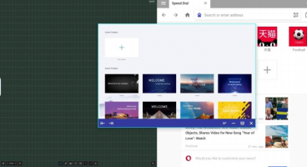
1) Under the main account, enter the Settings -- System -- User, and
turn on the multi-user switch to add a user;
2) Click "Add User" to enter the page for adding a user;
3) Type-in the user name, role and password to complete the
creation.
4) After the addition, click "Exit current user" in the Launcher to enter
the user switching page；
5) Select the user and input the password to enter the corresponding
user management.

Multi-User Management:

Primary users can manage users on the current device. Common
users can only manage their own accounts. Visitor users have no
account management rights. Account management support:

· Changing passwords according to the scheme: Each user can set
their own password to protect their privacy.
· Password reset: The primary user can reset the passwords of other users to prevent the user from being unable to access the account if the user password is lost.
· User name change: Click to edit the user name, replacing the
current user name.
· To delete an account, the primary user can delete other accounts,
and all user information is deleted after an account is deleted.

10.Multi-window
Multi-window is to facilitate users to operate the functions of
different applications at the same time, and display different
contents at the same time. The basic operations are as follows:

Opening Multi-Window. :
Users can open multiple users in two ways:
On the menu screen,long press an app icon to pop up a management window, opting for a 'free window' to open your app.
In the sidebar app management, users can directly access apps in free window mode by long pressing and clicking on them.
When using the app, use five fingers snap together in the middle of the screen, users can quickly enter the free window mode.

Multi-Window Operation:
After opening multi- windows,you can click the corresponding window to select it at the bottom of the apps, and perform the following
operations on it.
Dragging: You can move a free window by pressing and holding the control bar at the bottom of the screen;
. Scaling: Select, press on the edge of the free window and drag to scale the width and height of the window, and click on the corner to scale the width and height at the same time.
Left and right edge scaling: Tap the scale button on the left side of the control bar to scale an app by the left/right side of the screen. Operating two applications at the same time can achieve left and right split screen;
· Restoring the original size: Click the Restore icon on the right side of the control bar to restore the window to its original size.

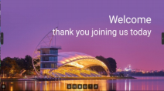
. Minimization : Click the Minimize icon on the right of the control
bar to fold up the app, which can be found in multitasking.
. Maximization: Click the Maximization icon on the right of the
control bar to apply a full-screen display.
Close: Click the close icon on the right of the control bar to close the current application.
11.Welcome page
Multiple templates is built in the welcome page.You can click to enter. Users can modify and save the template as a new one.
After entering the template page, users can modify the background,
text, music, etc., after the setting, click the button ‘play’ to display;
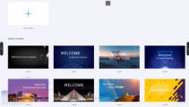

12.Screen recording
1) Click the application icon to enter the application, and the application will open in a small window.
2) Click“ ”, you can start recording, start timing and recording screen; Clicking“ ”again can pause timing and screen recording ;
3) Click “ ” to end screen recording, and the saving option pops up;
4) Click “ ”to minimize the application, fold up the screen recording
function and display it as a square dot;
5) Click “ ”to close the screen recording. If the screen recording is
in progress, it will prompt you to save;

13.Screen shot
Screenshot can quickly capture and save the screen content ; 1) Click on screenshot icon on sidebar or compass to
2) Drag the screen shot circle to move the screen shot position
3) Drag cross point to change the length and width of screen area .
4) Click in the right corner to open the whiteboard and place the screenshot into the whiteboard
5) Click in the right corner for a full-screen screenshot;
6) Click in the right corner to close the screenshot function;
7) Click in the right corner to confirm the screenshot and prompt to save;
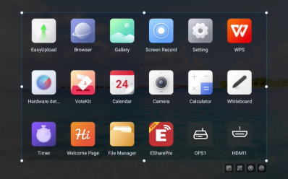

14.Gallery
1) Click the application icon to enter the app; Or select the picture in the folder to open, enter the application;
2) App renders image preview and navigation;
3) Slide left and right to turn pages for display;
4) Click the control bar at the lower left corner, you can do the
previous page, next page, flip, rotation and other operations on the picture;

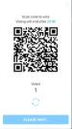
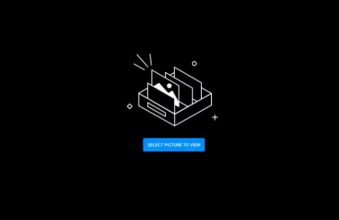

15.Voting System
1) The voting device can be used only with network support. If there is no network, this function is unavailable.
2) Click the app icon to enter the app.
3) Display the voting theme and option setting page, click the input
box to invoke the keyboard input;
4) Click "Reset" to clear options and themes; Click ‘Next’ to set
single/multiple, anonymous/real name requirements;
5) Click "Start voting" to present the QR code of voting. Participants
can scan the code to vote and the voting results will be updated
in realtime;
6) Click "End voting", the voting ends, the QR code lose efficacy,
the voting page is closed; Present the poll results;
7) Click ‘Save’ to save the voting result; Click "Place whiteboard" to
insert the voting results into the whiteboard display.
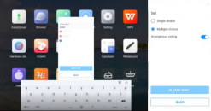

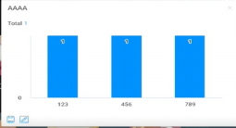
16.Easy Upload
Easy Upload is an application that can quickly upload pictures and text from mobile phones to the IFPD for sharing and display.
The basic operation process is as follows:
1) Click the application icon to enter the app;
2) Scan theQR code on the screen with your mobile phone to enter the page of easy file uploading;
3) Select the local picture or input the text content on the mobile
terminal and click Add to enter the uploading and sending process;
4) After uploading successfully, the machine will display the recently uploaded picture or text content;
5) Click the "Insert whiteboard" icon in the lower left corner of the
content to open the whiteboard and place the selected picture into the whiteboard;
6) Click the "Delete" icon in the lower right corner of the content to delete the currently selected picture or text;
7) Click the "Minimize" icon in the upper right corner of the application box, and the easy upload application will be minimized . After the
application is minimized, it will be displayed at the top of the page in the form of floating window;
8) Click the "Close" icon in the upper right corner of the application
box to close the easy upload app. After closing the app, all uploaded
content will be cleared and no local saving will be performed.
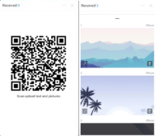

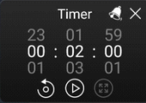
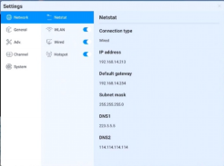
17.Timer
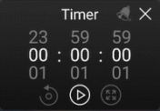
The functions of the timer and stopwatch in one are as follows:

Stopwatch:
1) Click the application icon to enter the application, and then the
page will display 00:00:00;
2) Click Start to enter stopwatch function;
3) During the stopwatch fuctioning, click to pause the timing; Click
the reset button on the left to reset the time to zero. Click 囤
to enlarge the full screen to enter the full screen display;
4) Click "Close" in the upper right corner to close the application;

Countdown Function:
1) Click the application icon to enter the application, the page will
display 00:00:00;
2) Adjust the time to non-zero and enter the countdown function.
Click "Start" to enter the official countdown;
3) Click the bell icon to open the dot reminder function. When the
countdown ends, the system will have a voice reminder;
4) Click Reset to restore the preset countdown time;
5) Click "Close" in the upper right corner to close the application;

18.System settings
18.1 Network

Netstat:

WLAN:
Turn on the wireless network and automatically scan the available wireless network nearby
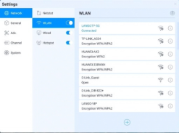
1) On-Off: Turn on/off wireless network
2) Refresh: Click refresh icon in the top-right corner to refresh Network List
3) Add: Click Add button to fill in network name and password to add hidden network
4) Connect: Select the network click connection, fill in the password connection

Ethernet:
1) Turn on the Ethernet network and appear access to IP option 2) Automatically access the IP connection network
3) Manually enter IP address, default gateway, subnet mask, DNS1, DNS2 settings

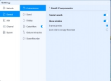
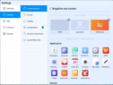
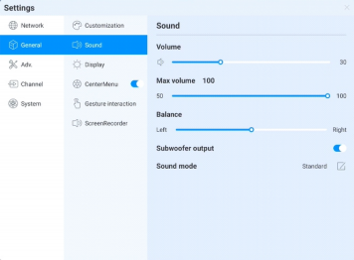
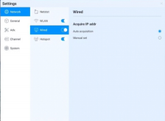

WiFi-AP :
1) WiFi-AP Password:Displays the current WiFi-AP password, click
to change;
2) Connected devices:Display connected devices;
3) Blacklist :Display blacklisted devices which can not be connected
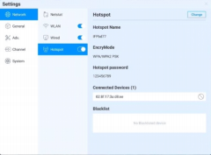
18.2 General

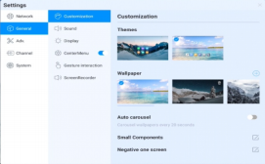

1) Theme:The system provides 2 sets of themes by default. Choose to switch themes to present different UI effects on the homepage.
2) Wallpaper: The system provides 10 pieces of wallpaper with
automatic rotate multicast;click users can upload the customized wallpaper;
3) Small Components: Prompt language switch, control whether page prompt language will display; Display window, can control the switch and display content,also can choose the two fuctions of sourcing
and scanning code to occupy the screen;
4) Negative screen:The negative screen is the page with the left and right slide into the Launcher home page. After entering the function, the user can drag the app to the corresponding page to take effect

Sound:

Sound setting is used to adjust the sound effect of the system, adjustable content :
1) Volume:Adjust the volume,also can adjust by pushing the “volume+”
and “volume-”button on remote control or device button 2) Maximum volume:Sets the system maximum volume 3) Balance: Balance the left& right channels
4) Sound mode: preset standard, conference room, cinema, classroom four sound modes, but also support customizing;

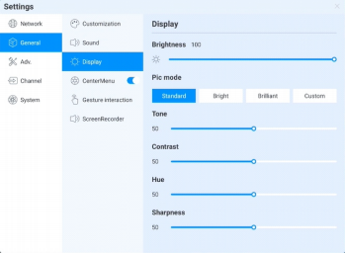
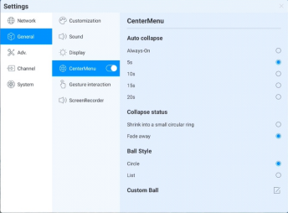
Display:

Display settings can adjust display effect of the screen,
1) Brightness:Adjust backlight brightness, the lower the value, the
darker the picture;
2) Image mode :System default image mode:standard, bright, bright-
coloured,but also support customizing;

Compass :

Compass setting is mainly to adjust the compass switch, display time,
display style and other functions, specific as follows:

1) Switch:Click the compass switch, you can switch the compass
display state, can not be called out under the closed state,you can long press the compass with five fingers to open the compass under the open state
2) automatically rewind time setting: Click to select the corresponding rewinding time.
3) Fold up state: choose to fold into a small circle, compass fold the surrounding tool options only, keep the circle in the center, click to expand; choose "disappear", compass fold up and disappear , not shown in screen, need five fingers long press to open;
4) Compass form:It supports two forms ofwheel and list
5) Compass customization:You can customize the last three application icons on the compass,as the pictureshow,drag the application to the location to add:

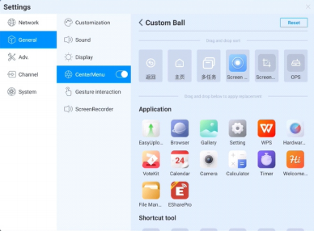

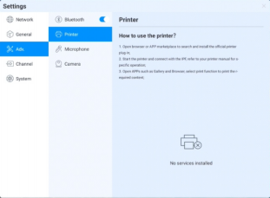

Gesture interaction: 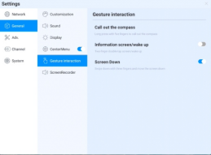
The system has preset some gesture interactions where the users
can switch settings:
1) double click with two fingers to asleep or wake up the screen;
2) Move down the screen:slide down with three fingers to move
down the screen on channel page

Screen | recording: | 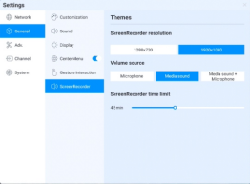
Preset the screen recording function, including:
1) Recording resolution:Three resolution are optional
2) Sound source:Set up the sound source for the screen recording
remix
3) Recording time limit:Maximum recording time, when the maximum recording time is reached it will prompte to save;
18.3 Device
Device control page, mainly adjust the external equipment of
the device, including Bluetooth and Bluetooth devices, printer,
microphone, camera

Bluetooth:
1) Bluetooth function depends on model configuration
2) Enable the Bluetooth functioned , you can search for devices and transfer files ,or find and connect other Bluetooth devices (Including but not limited to mouse, keyboard, headset, audio, mobile devices, PC, universal / unidentified devices)
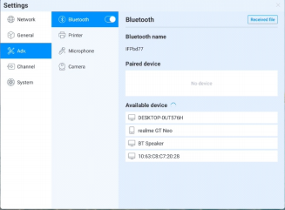

Printer：

Install the print service according to the instructions
Turn on the print service to get the available printer terminals

Microphone:
View the connected microphone device,all devices are presented in
list, click to switch
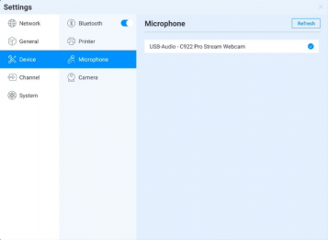
Camera：
View the connected camera device,all devices are presented in list,
click to switch

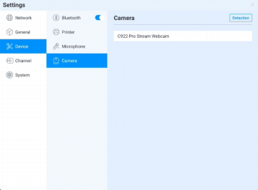

18.4 Input Channel
Channel image：
1) Describes the status of the current access source
2) Scale mode:Set the display scale of the current input source 3) PC mode:select screen display mode
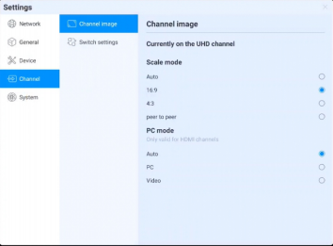

Other setting：
1) No signal jump:If the current channel has no signal, the page will automatically switch, and the user can customize the jump
page;
2) Automatic jump:When the system is running, access the new signal source, it’ll automatically jump to the corresponding
channel;
3) Automatic wake-up: Under standby or sleep state, access the signal source and automatically wake up the device;
4) Boot channel: Set up to access to a channel after the boot, can be set to andriod or each source interface;
5) Channel name customization: There are many signal sources and names in the system, users can customize their familiar names, the system will display the new signal source name after customized;

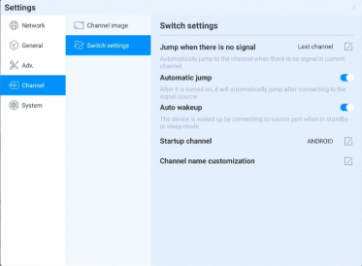

18.5 System
The various system parameters can be adjusted and viewed in the
system settings,including:Date and Time, Language and keyboard,
Power state, System update, System security, About.
Date and Time：
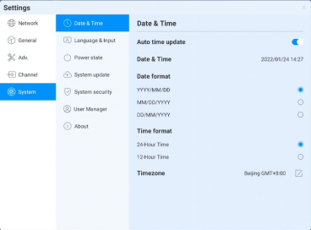

1) utomatic update:Enable to synchronize network-time(Need to connect to the Internet))
2) Date and time: Turn off automatic update,click to adjust the date and time;
3) Date format:Three date-display format, according to your habit to choose one ;
4) Time format:Two time-display format,according to your habit to choose one;
5) Time zone :Set time zone , click to enter the time zone selection list

Language and keyboard：
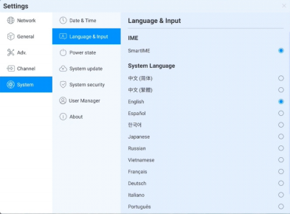

1) Keyboard:Users can select input method here
2) System Language:System language can be switched in Simplified Chinese,Traditional Chines,English,French,German,Russian,
Japanese,Korean,Polish,Portuguese,Vietnamese,Spanish,Italian, and Arabic .

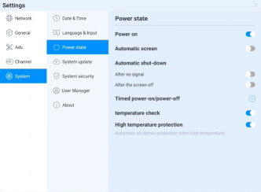
Power state：

Power on:After opening, the device directly enters the boot state when
it is powered on; Otherwise, the standby mode is used by default.

1) Automatic screen sleep :Choose this fuction, you can set the
screen rest time. The screen will turn off at the end of the screen
sleep time.
2) Auto power-off, you can set the automatic power-off mode, you can choose to automatically power-off after no signal or automatic
power-off after screen sleep.
3) Auto On/Off :Set time to auto on/off.
4) Temperature detection: The upper right corner status bar will
display the current device temperature, you can see temperature
status in the status bar
5) Temperature protection: When the temperature ≥85℃ , it will
forced shutdown to protect the device

System update：
1) System update: Display the current firmware version, click refresh
to detect the latest version. When there is a new version, present
the update version button, click to enter the upgrade process
2) OTA server: Use OTA push to detect new version automatically in
networking, you can customize OTA server address

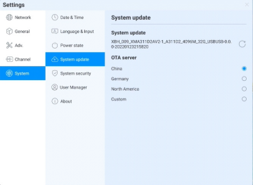
System security：
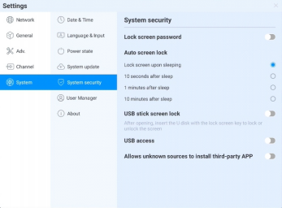
1) Lock Screen:You can set the pattern or password to unlock. If you forget the password, you can only restore the equipment use by factory resets, please keep it properly
2) Auto-screen lock:
3) U Disk Lock Screen:Store the "usb_key" file in the root directory of the USB device. Automatically lock screen / unlock after receiving USB flash drive, no need to enter password to unlock

U disk lock screen / unlock file
① New text document
② Entering U2FsdGVkX19eyanxj43a24KpK3kZmzB9
③ Name the file usb_key
④ Delete the file suffix name .txt
⑤ The character is UTF-8
⑥ Saved and place it in the root of U disk
⑦ Insert the U disk to unlock
4) USB Permission：If the permission is enabled, USB reading is
disabled for protect file from copied(you need to set a password at
the first time, if you forget the password, you can only restore the
equipment use by factory reset,please keep it properly); you need
to enter password to gain access to the USB stick.
5) Allow third party applications installation from unknown sources:
Users can install third party applications , or can only download and
install applications from the Google Store
Multi-user：

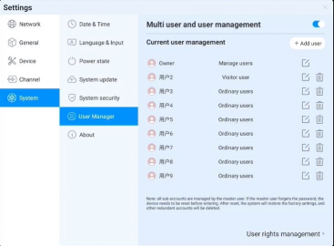
Refer to above, multi-user function introduction

About：
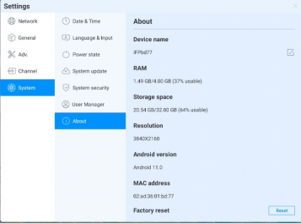
Click to view device information ;
1) Device name:Click on it to edit the device name
2) Factory reset: Factory reset will delete all operation records and content, and restore the devicet to the factory state

Simple Troubleshooting
Maintenance can prevent small problems from becoming big problems and ensure the safety of the machine .
Maintenance can maximize the performance of the machine and achieve a longer service life .
Maintenance tools:
Clean a lint-free cloth , such as a dust-free cloth . Cleaning agents , such as industrial alcohol
Maintenance measures:
Before maintenance , turn oﬀ the whole machine , turn oﬀ the power I/O switch ,and unplug the power cable to ensure your safety.
Soak the cloth in the detergent and twist it to half dryness without dripping water.
Wipe the dust on the surface of the protective glass of the screen and the frame of the whole machine .
Wipe 2 to 3 times, preferably with a new clean cloth to dry the remaining detergent .
After the cleaning is completed , the standby device can be used normally after the water is naturally dried.

Before preparing to repair, read the following table to see if you can ﬁnd the fault you are
encountering the reason. When you are sure that you follow the instructions on this page
completely and still cannot eliminate the fault,Please contact the product service center for
product repair.

Maintenance

The importance of maintenance:

System error
Phenomenon | Solution
No picture or sound | Check if the power cable is connected to the wall outlet
 | Check if the signal cable is properly connected
 | Check whether the power switch of the external device is turned on
 | Make sure the machine is not in standby
The picture is  normal without  sound | Check if the volume is set to minimum
 | Check if the volume is set to mute
 | Check if the external audio is properly connected
No picture or  picture is black  and white | Check and adjust color settings
 | Check and adjust the color system
Sound and  image are  disturbed | Try to ﬁnd the electrical appliances that aﬀect the all-in-one and keep it away from the all-in-one
 | Try to plug the power plug of the all-in-one into another socket
Blurred picture  or distorted  snowﬂake  image | Check whether the signal line connection is loose
 | Set again and micro signal input
Remote control malfunction | Check if the remote control battery is installed correctly
 | Check whether the battery of the remote control is exhausted , and replace the battery in time
 | Check whether the polarity of the remote control battery is installed in the correct direction
 | Check whether there are foreign objects obstructing the position of the remote control signal emission

Develop good machine habits
When the machine is not in use, please turn oﬀ the power I/O switch or unplug
the AC power cable. If you do not use the machine for a long time, please wrap
it in a protective cover and store it in a cool and dry place .

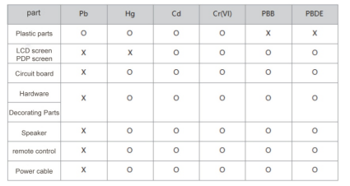
Name and content of toxic and hazardous
substances or elements in the product:
0: Indicates that the content of this toxic and hazardous substance in all
homogeneous materials of this part is below the limit requirement of
SJ/T11363-2006
X: Indicates that the content of the toxic and hazardous substance , in at
least a certain homogeneous material of the part , is above the limit
requirement of SJ/T11363-2006

Technical Description:
The hardware structural parts , injection molded parts , connectors and most
of the electronic parts of this machine comply with the requirements of China
and EU RoHS directives. Only a few parts, due to the global technical
restrictions and the fact that it may aﬀect product reliability, have not been
replaced by Non-toxic and harmless substances or elements yet. However,
consumers should rest assured that it will not cause health damage to users
under normal conditions of use .

