>>> HM87-I7-4600M+4G+128G Catalog <<<
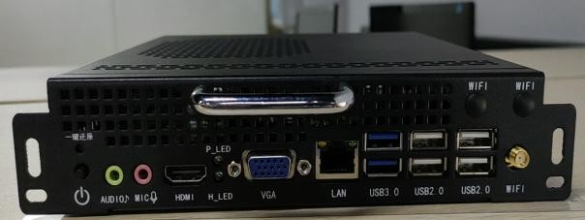  Photo | Main Spec:
 | 1. Front VGA+HDMI port, easy to use.
 | 2. Build in WIFI.
 | 3. Support gen4 CPU.
 | 4. One key to recover OS, Wake-on-LAN, resume by alarm.
Processor | Chip | HM87
 | CPU | Intel® Core™ i7-4600M
 | Performance Spec. | # of Cores: 2 # of Threads: 4 Processor Base Frequency: 2.9GHz
Memory | Technology | 1 x SODIMMs DDR3
 | Memory | 4G
Display | Front Output | VGA-Max.1920 x 1080
 |  | HDMI-Max.1920 x 1080
 | JAE Connector | HDMI-Max. 3840 x 2160@30hz
Processor  Graphics | Model | Intel® HD Graphics 4600
 | Base Frequency | 400 MHz
 | Max. Dynamic Frequency | 1.30 GHz
Hard Disk | SSD | 128G
Network Adaptor-  Dual Band 5G | Interface | PCIE
 | Support | Dual Band 2.4g/5g
 |  | Gigabit LAN Controller
I/O Port | JAE Connector | 1(JAE TX25 80-PIN)
 | VGA | VGA-Max.1920X1080
 | HDMI | HDMI-Max. 3840X2160@30HZ
 | LAN | 1(RJ45. Gigabit)
 | USB | 2 x USB3.0 & 4 x USB2.0
 | AUDIO | 1 x AUDIO OUT + 1 x MIC IN
 | Serial Port | 1 x RS232 COM & TTL OUT (Alternative)
Extension Port | Mini-PCLe  (built-in) | 1 x Mini-Pcie
 |  | 1 x Msata
Power | Input voltage | DC-IN 12~19V
Physical | Size | 180 x 195 x 42 mm
 | Material | Metal
Heat Dissipation | Dissipation | Pure aluminum dual-ball fan for cooling and temperature control
Environment | Temperature | 0 - 55℃
 | Humidity | 95% @40℃(Non-condensing)
Software Development Kit | OS | Windows® 7 Windows® 10
 | Power on automatically | Support, hardware control power-on automatic boot, motherboard jump cap mode.

SIZE