PRODUCT INSTRUCTION MANUAL
All rights reserved. Unless allowed under copyright laws. Otherwise, in the case without prior written permission is prohibited reproduction, adaptation, or translation of this book. Associated with this user manual have the following powers: A: To print the manual to get their hard copy for personal, internal, or corporate purposes, and not for sale, resale or distribution purposes;
Document declaration
The information contained herein is subject to change without notice. The Company does not make any guarantees in this book. The book contained an error by the company for its supply, performance or use of the incidental or consequential damages shall not be liable.
- Features Environmental Indicators
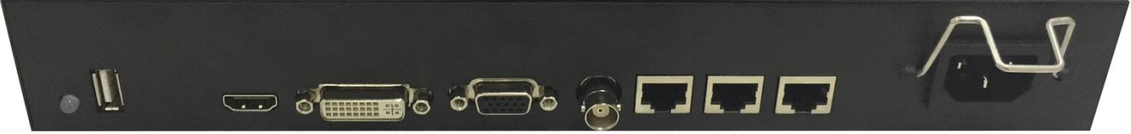
input | CVBS x1 | The interface is BNC
 | VGA x1 | Support VGA (1920×1080)
 | DVI x1 | Support DVI (1920×1080)
 | HDMI x 1 | Support HDMI (1920×1080)
 | USB x1 | USB2.0
 | RJ45x1 | RS232 IN PUT
output | RJ45x2 | RS232 OUT PUT

Working temperature | 0℃-50℃
Working humidity | 5～80％RH

1.1 Features
• Full hardware architecture, no CPU and operating system;
• Multi-bus parallel processing, handling and powerful;
• Start-up time of less than 8 seconds, start quickly;
• No risk of virus infection, good security;
• Integrated multi-channel video signal source types: DVI, HDMI, composite video, VGA;

1.2.USB power upgrades
Using the USB port of the board card，you can easily upgrade the software at the construction site.Use a U disk，you can splice a project officer for the entire system M56W module to do all the upgrades, as long as the U after the disk memory into the software to be upgraded,use the U disk connected to the corresponding M56W machine,and then re-AC, M56W board card detected automatically after the software upgrade into the upgrade module, the corresponding power indicator light flashes prompted to upgrade, lights do not flash until the upgrade is complete.

1.3.Troubleshooting
When the product fails, turn off the power immediately, please do not attempt to disassemble the unit for repair, the product may cause further damage. The following steps can be ruled out, still can not be solved, please contact your local dealer or qualified service personnel. For the user to repair the product, not the company's warranty.

It is like | Approach
Does not boot（power light is off） | 1、Check that the power cord is damaged;  2、Whether the power is access to electricity;  3、Make sure the power is turned on;  4、Is the power switch is damaged;  5：It is blown fuse。
All splicing unit uncontrolled | - Check the stitching software port settings are correct；  - check the serial cable is damaged, and whether the PC interface products and good contact;  - PC's serial port to check whether there is a problem, you can replace the PC test;  - Address splicing unit is set correctly, see the address settings.
Uncontrolled individual splicing unit | - Check the address of the device settings are correct.  - Individual control of the device was successful.
Single or multiple devices VGA / DVI no input | - Check unit board and the signal source end of the interface is a good contact;  - Replacing a VGA or DVI cable test;  - The device is set in the input status;  - The input signal exceeds the input range of the product;  - When the DVI input, make sure there is caught DDC, and there is output.

1.4.Performance
Operating temperature：0℃-50℃
Working humidity：Relative humidity less than 80%
Composite video Peak：1Vp-p
VGA input：WUXGA（1920*1080）

2.PC software for use
This chapter provides instructions for using the PC software, including the following information:
- .software operating environment
- .Software installation

2.1Hardware configuration requirements for computers
The computer hardware configuration requirements for installing the software are shown in table：
Configuration requirements | Minimum configuration
CPU | surge forward 133Mhz
RAM | 128MB RAM
Monitor | 1024x768resolution display device
HDD | 150 MB of free hard disk space
Input device | Microsoft copatible mouse and keyboard  Standard RS232 communication interface

2.2.System software requirements
The operate systems support by that computer system are shown in the table：

support system | Remarks
Windows XP | 32/64bit
Windows 7 | 32/64bit
Windows 8 | 32/64bit
Windows 10 | 32/64bit

Note: computer systems must have NET Framework_4.0。

2.3Software Installation
Copy the installation package to the computer, run the software installation program, according to the operation prompt to complete the software installation, in this case in window 7 system computer installation, for example, the installation steps are as follows.
1)、Copy the screen control installation package to your computer and unzip the files。create a ScreenControl shortcut on the desktop.
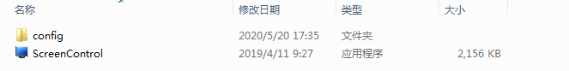
Figure software in screen control installation package

3.Start systems

1）Before the system is running, to ensure normal following link：
1、RS232 line computer running the software is properly connected to the controller；
2、Related controller signal cable, power cord is connected properly；

2）System operation step：
1)、Turn on the controller power, control power indicator lights；
Green, representing the operating state is switched; orange for standby。
2)、Running the software

Find control software folder, click FWM.exe run. Program user interface as follow:
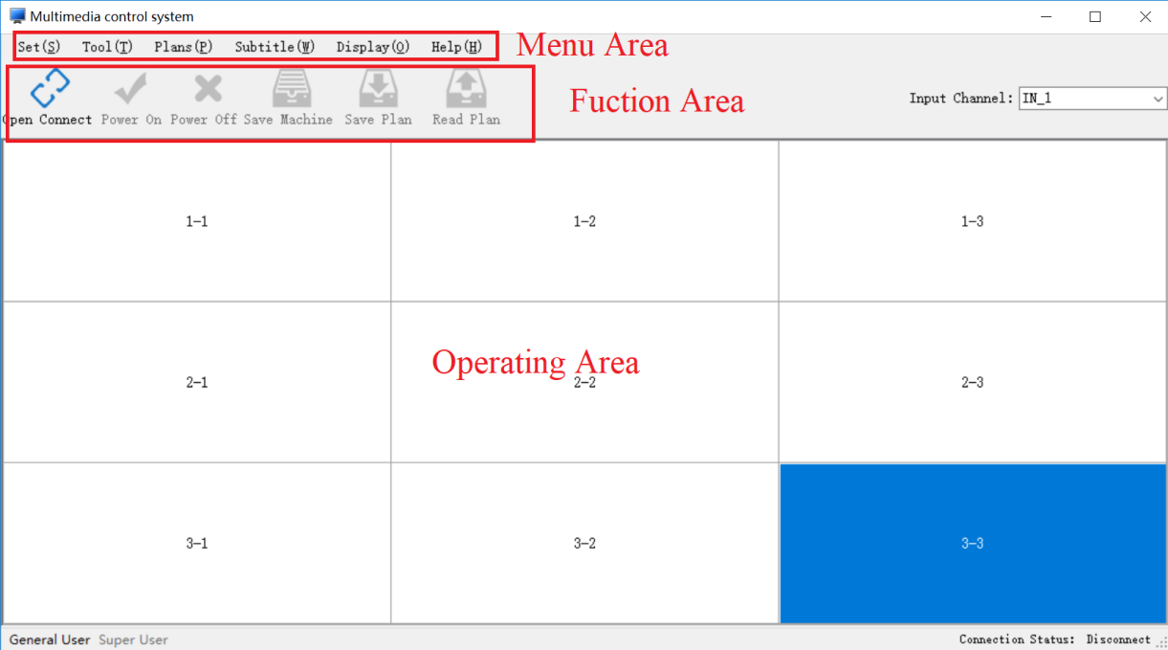

4.The function of Screen Control splicing controller software is introduced.：
ScreenControl software main interface is divided into general user interface and super user interface.。
- main interface
- Menu bar function
- Toolbar function
- Operating area

4.1.main interface

Regular users and super user switching.
When you open the software, the main interface is the common user interface, from
the ordinary user to the super user.，Please click on the main interface status bar "super user"
，Pop "enter password" window, enter password "123321"，Click the "ok" button or press the
"Enter" button,You can enter the super user interface.
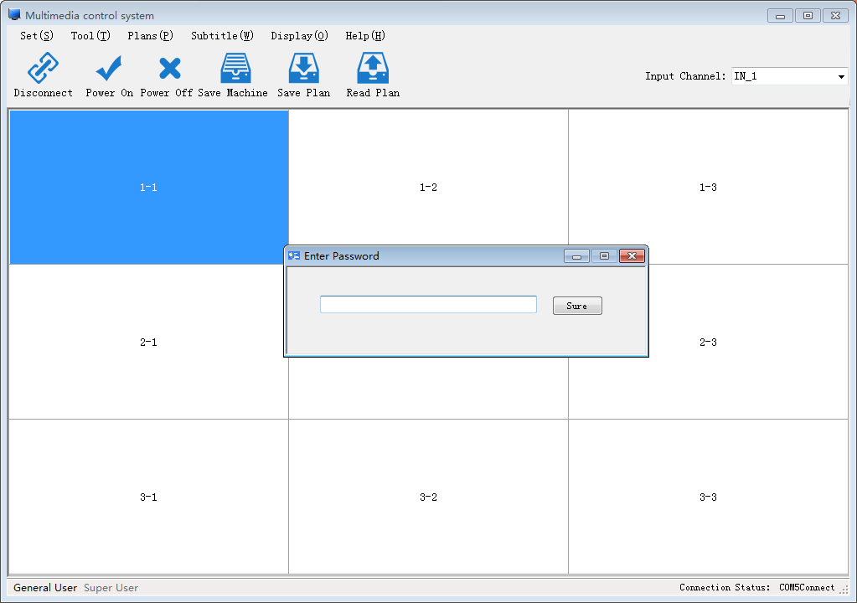 Ordinary users switch to super users.

Super user interface:：
Super user interface mainly consists of menu bar, toolbar, operation area, additional function, command display and status bar.
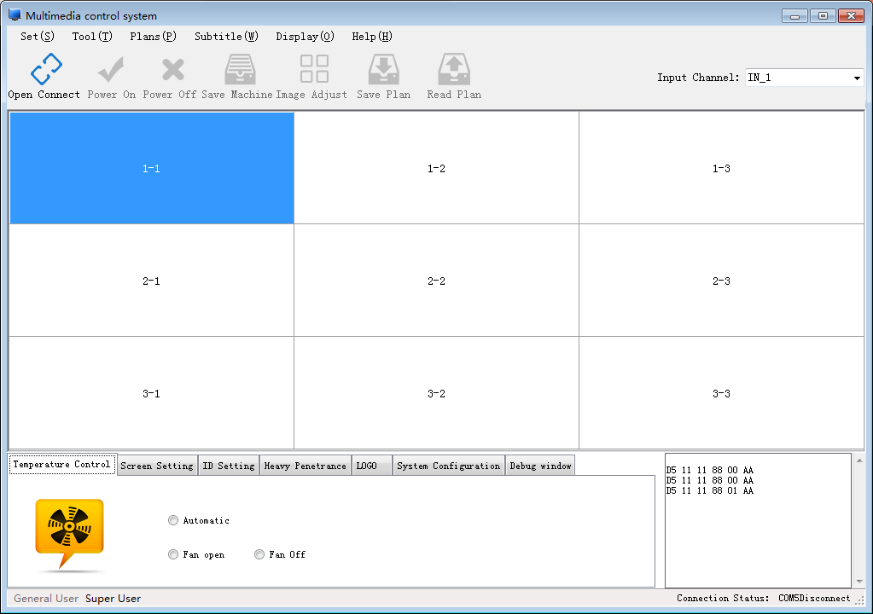
Command to display
Status bar
Toolbar
Menu bar
Additional features
Operating area

4.2.Menu bar function

4.2.1 Set
Com Settings
Before setting up communication, check the connection between the computer and the device. After opening the connection, no communication setting can be made.
Enter the "com Settings" interface；click "Settings" in the menu bar of the software main interface，in the drop down menu, click "com Settings" to enter the com setting interface.。
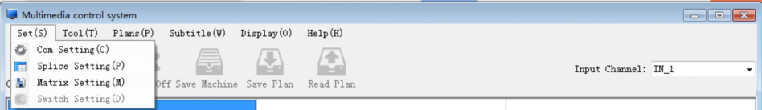

Com setting interface：Shown below，Including splicing equipment, video matrix, VGA matrix, DVI matrix, HDMI matrix network connection Settings, serial port connection Settings, matrix linkage Settings.Note: the communication Settings are set before the connection is opened, and the communication Settings cannot be set after the connection is opened.
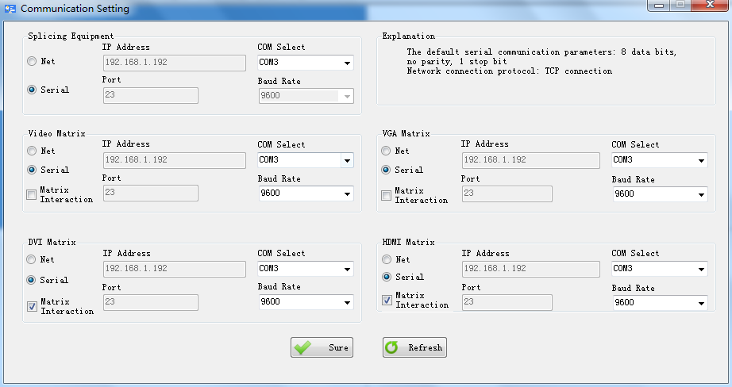

1）Network connection：select "network connection"，Set the IP address and port number to connect to.
2）Serial port connection：select "serial port connection"，Set the COM port and baud rate to connect. Click the refresh serial button to refresh the COM port.
3）Matrix linkage：Select "matrix linkage", can conduct matrix linkage.

How to know which COM number
PC serial port settings and view：Right-click the "My Computer"－“Management”－“Device Manager”－“Ports (COM and LPT)”
View the PC's serial port.
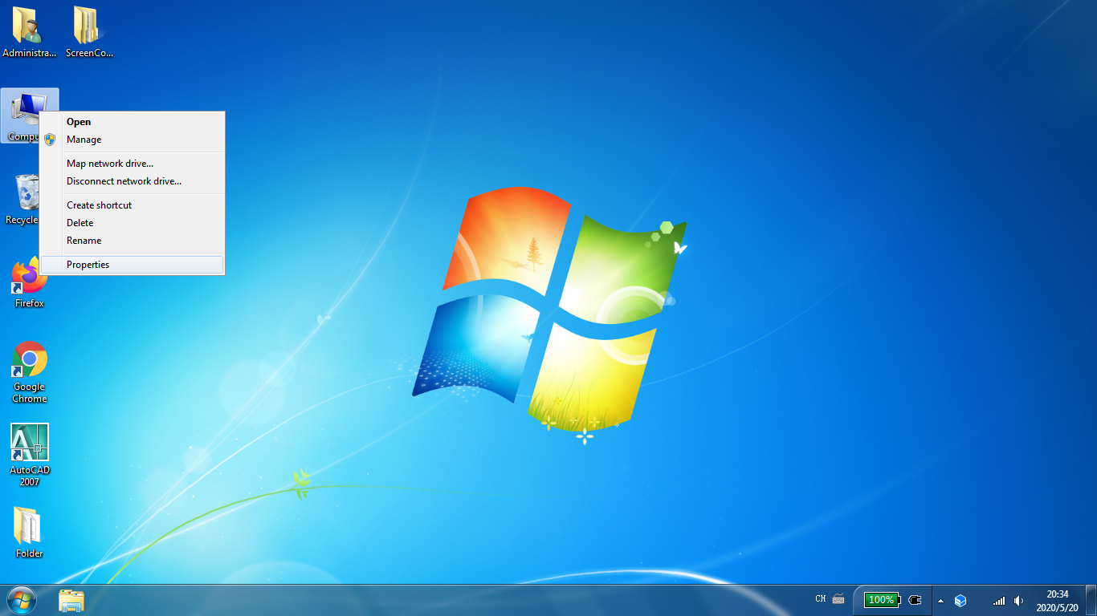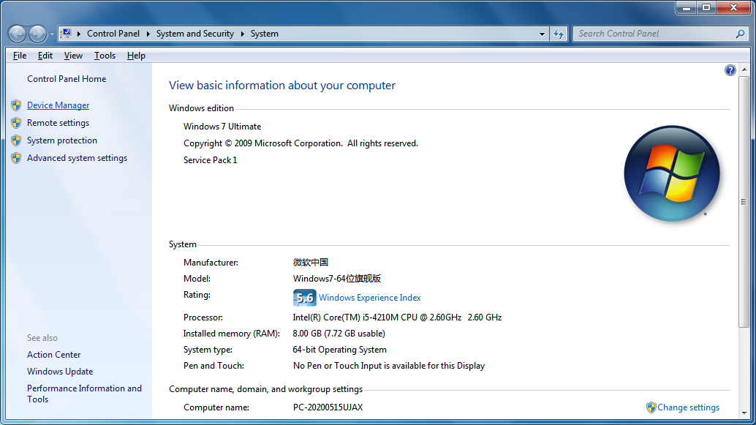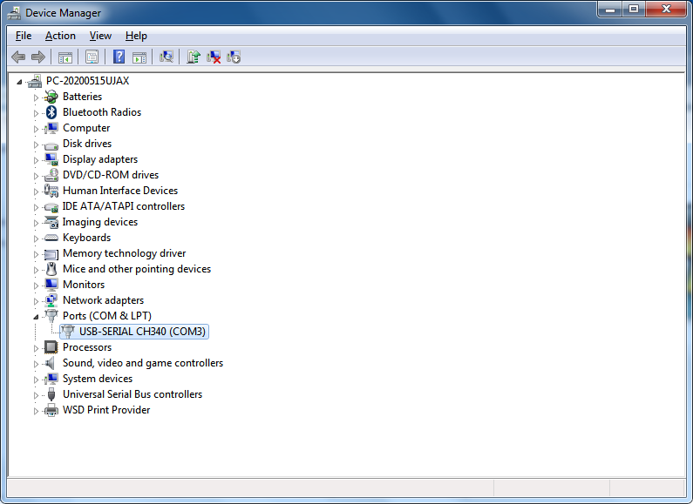

Splicing Setting
1、Enter the "Splice setting" interface: click "Settings" in the menu bar of the main interface of the soft nail, and click "Splice setting" in the drop down menu to enter the interface of splicing Settings.Shown below.
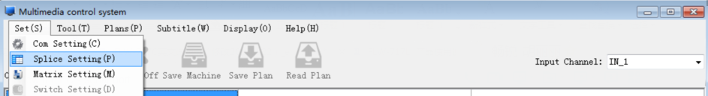

2、Splice Settings interface：Includes the row and column Settings of the splicing screen.The two modes choose the free mode and fixed mode, and the fixed mode is recommended. Shown below：
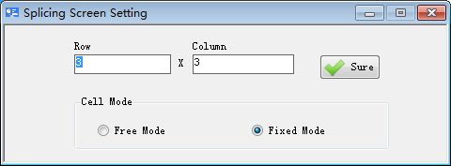

1）Column setting: keyboard input line number and column number, click ok button.
2）Free mode: select "free mode", the width and height of the grid can be changed at will.
3）Fixed mode: select "fixed mode". The width and height of each grid are fixed and cannot be changed. "fixed mode" is recommended.。

Matrix Setting
Before you "open the connect",set the matrix，After you"open the connect", you cannot set the matrix.。
1、Enter the "Matrix Setting" interface：Click "Set" in the menu bar of the soft nail home screen，Click "Matrix Setting" in the drop down menu that appears，Enter the "Matrix Setting" interface Setting。Shown below：
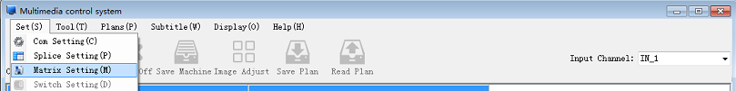

Matrix setting interface：Including Video Matrix、VGA Matrix、DVI Matrix、HDMI Matrix The protocol selection and ID Settings of the four matrices，Response Time、Intervals Time、Screen and matrix Instruction preference，Input Channel Setting，Port Mapping，Add Protocol。Shown below：
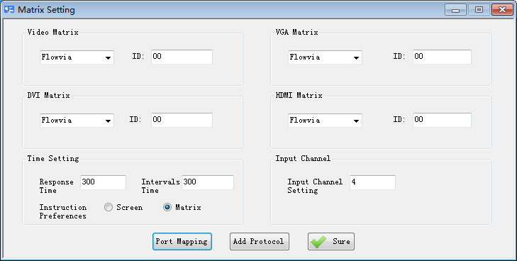

1）Matrix protocol selection：Under the corresponding matrix, select the corresponding protocol.。
2） Matrix ID setup ：Under the corresponding matrix, the keyboard input id number。
3） Time Setting：Fill in the time required after the response time and interval.
4) Instruction Preferences：Select "screen"，Screen instructions are sent first，Select "matrix" and the matrix instruction is sent first。
5）Input Channel Setting：Set the maximum value of the input channel according to the number of channels.
6）Port Mapping：Please refer to the port mapping Settings.
7）Add Protocol：Please refer to the add protocol.

2、Matrix Output Setting：Click the "port mapping" button of the matrix setting interface,Pop up matrix output interface，Including Video Matrix, VGA Matrix, DVI Matrix and HDMI Matrix output Settings.Shown below：
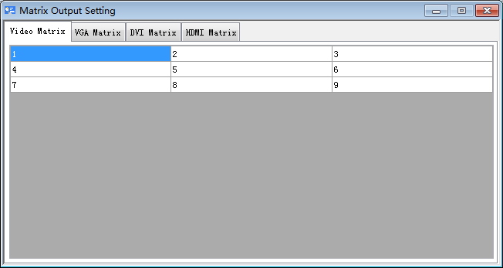

1）Matrix selection：To set the output of the matrix, select the matrix you want to set.。
2）Output Settings：To change the output, select the number in the table and fill in the output channel that needs to be set.

3、Add Protocol：Click the "Add Protocol" button of the matrix setup interface,Pop up the Add Protocol interface，There are two types of adding modes.1：A string type protocol.，2：Hexadecimal type protocol.。As shown below：
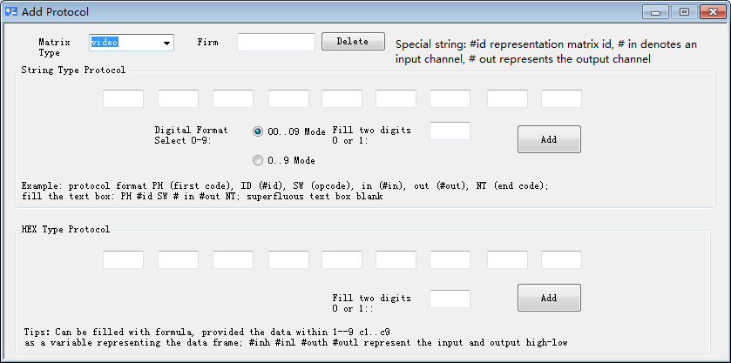

Switch Setting
Before setting the switch, make sure to open the communication connection. If the communication connection is not opened, it cannot be set by the switch machine.
1、Enter the "Switch Setting" interface：Click "Set" in the menu bar of the software main interface，Click "Switch Setting" in the drop down menu, and enter the interface of the Switch machine. Shown below：
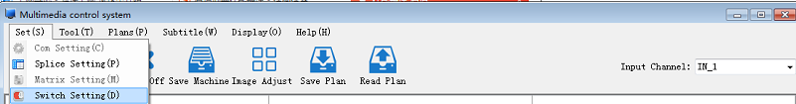

2、Switch Setting interface:Including Delay Switch Machine time setting,Timer Switch time setting.Shown below：
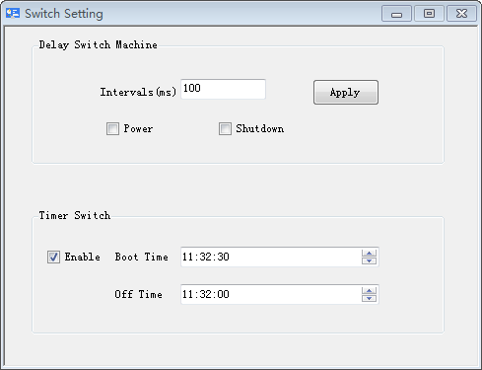

4.2.2.Tool
Frame Effect
Before using the "Frame Effect" feature, make sure you open the communication connection.If the communication connection is not open, you cannot use the "Frame Effect" function.
1、Enter the "frame effect" setting interface, and click "tool" in the menu bar of the main interface,Click "frame effect" in the drop down menu to enter the frame effect setting interface,Shown below：
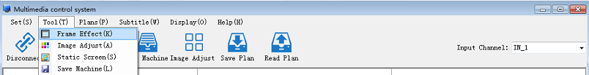
2、Frame effect setting interface:including Horizontal Adjust，Vertical Adjust。After adjusting to the required frame, click the apply button, and if you want to recover to the initial state, click the reset button.Shown below：
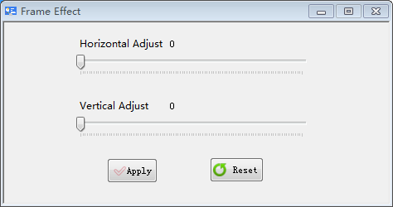

Image Adjust
Before using the "image adjust" feature, make sure you open the communication connection.If the communication connection is not open, you can't use the "image adjust" feature, only the super user can use this feature.
1、Enter the "Image adjust" setting interface, and click "tool" in the menu bar of the main interface.Click "image adjustment" in the drop down menu, and enter the interface of image adjustment.Shown below：
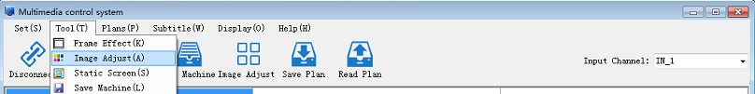

2、Image adjust setting interface：Including Color Adjust，VGA Fine Adjust,Backlight Brightness Adjust.Shown below:
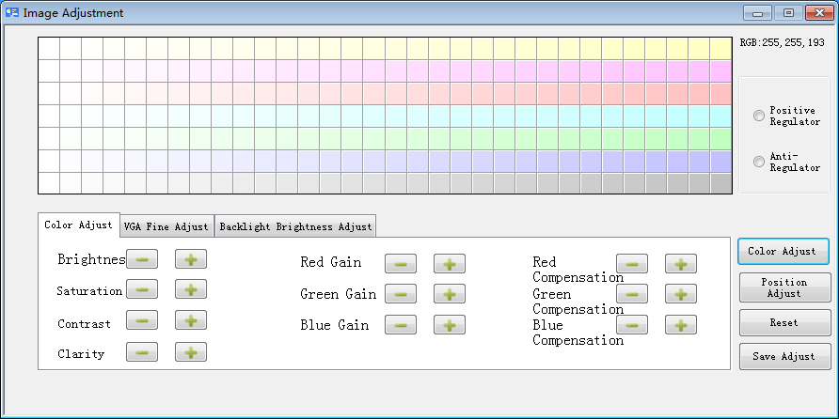

Scope of adjustment: is the coordinate unit area in the current operation area.All parameter adjustments will be valid for the selected unit area.
Color Adjust：
Image
Brightness:Adjust the brightness of the screen image;
Saturation: Adjust the depth of image color;
Contrast: Adjusts the brightness of the screen image;
Clarity: Adjust the clarity and focus of the screen image.
Color temperature
Red Gain：Adjust the color temperature to balance the red component, mainly affect the white field, the bright field;
Green Gain：Adjust the color temperature to balance the green component, mainly affect white field and bright field;
Blue Gain：Adjust the color temperature and light balance blue component, mainly affect white field and bright field;
Red Compensation：Adjust the color temperature dark balance red component, mainly affect the dark field, dark field;
Green Compensation：Adjust the color temperature dark balance green component, mainly affect the dark field, dark field；
Blue Compensation：Adjust the color temperature dark balance blue component, mainly affect the dark field, dark field;
Swatches:
1.First, make sure that the com setting is normal and can do basic control.
2.With administrator privileges, you can enter this adjustment area from the image adjustment option of the control software.
3.After all screens are switched to the unified channel, the signal picture is best for all-white field signal.
4.The principle explanation is to find a base screen on the splicing screen, then adjust the color temperature of the remaining screen to the same as the base screen, so as to achieve the result of the same color temperature effect.
5.Adjusted for use: First, determine whether the non-reference screen model is consistent with the reference screen, and then determine whether the screen backlight brightness to reach agreement with the reference screen, if not you can debug brightness backlight brightness or brightness, contrast parameters equivalent to as close to the base screen brightness. Then prepare to adjust the color temperature of the non-reference screen, first in the color table to quickly select and color similar to the color of the reference screen, and then manually adjust the color temperature of the gain / compensation of red, green and blue (gain mainly affects bright field, try to adjust the gain under the white field the RGB values; compensation mainly affects dark field), by fine-tuning reach base screen color consistent so far. Note: Positive reconcile anti-tune the color corresponding to the color table is the opposite, is positive tone screen colors and swatches of color is consistent, anti-tune the screen colors and swatches is the opposite, the default is the anti-tune settings Also you can pay attention to hover over the color table value corresponds to the block, this value shows the principle of complementarity of red, green and blue Huang Ziqing.

VGA Fine Adjust
Automatic adjustment: Under VGA channel, the system automatically adjusts image color and display position.
Note:The "automatic adjustment" process takes about 3-6 seconds, please don't do any other operation or turn off the power after clicking.
Reset：Click this button to restore the display unit of the selected region to the factory state.
Note:The "reset" process takes about 3-4 seconds. Please do not use any other operation or turn off the power after clicking.
For VGA signal, the second page (special adjustment) can be manually adjusted.
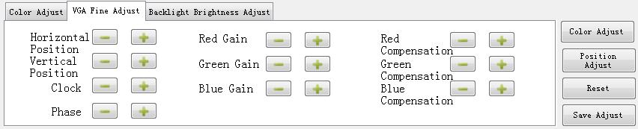

Horizontal Position：Adjust the horizontal position of screen image display;
Vertical Position：Adjust the vertical position of screen image display;
Clock：Adjust the vertical position of screen image display;
Phase：Adjust the image sampling phase.
These parameters are related to the implementation of "Position adjustment" in the PC channel. If the automatic adjustment cannot meet the requirements, such parameters can be manually adjusted (generally not recommended for manual adjustment).
Front-end brightness gain
Red: adjust the color temperature and brightness gain red component;
Green: adjust the color temperature and brightness gain green component;
Blue: adjusts the color temperature and brightness gain the blue component.
Under this kind of argument is PC channel, color adjust the relevant parameters, if automatic adjustment can not meet the need, can be manually adjusted, gain on behalf of the light field parameters, main show is contrast (general manual adjustment is not recommended).

Front-end brightness compensation
Red: adjusts the color temperature to compensate the red component;
Green: adjust the color temperature to compensate the green component;
Blue: adjusts the color temperature dark to compensate the blue component;
Under this kind of argument is PC channel, color automatically adjust the relevant parameters, if automatic adjustment can not meet the need, can be manually adjusted, the parameters of the compensation on behalf of the dark field, mainly for the ascension of brightness (general manual adjustment is not recommended).

Static Screen
Before using the "Static Screen" feature, make sure you open the communication connection. If the communication connection is not open, you cannot use the "Static Screen" function. Click "tool" in the main menu bar of the software, and click "Static Screen" in the drop-down menu that appears.Pop up as shown in the window:
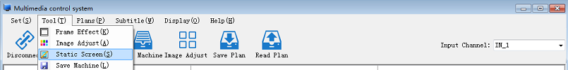

Save Machine
Before using the "Save Machine" feature, make sure you open the communication connection. If the communication connection is not open, you cannot use the "Save Machine" function. Click the function "Save Machine", as shown in the figure below:
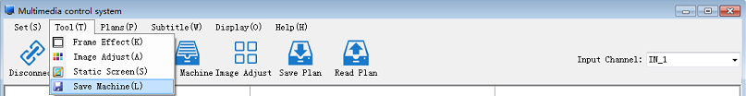

4.3.Plans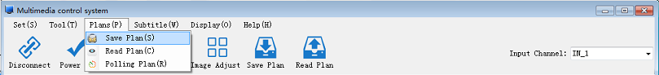
Plans include: Save Plan, Read Plan and Polling Plan.
Before using plan function to ensure that open communication connection. If there is no open communication connection, is can't use plan function.
1、Save Plan: the Plan can Save up to 16 plans, and if the Plan has been saved up to 16, "Full plans!!! "Prompt window, if want to continue to save preplan, want to delete already saved plan. Enter the "save plan" interface.Click "plan" in the menu bar of software main interface, click "save plan" in the drop down menu, and the "save plan" window pops up. The preservation plan name can be changed, as shown in the figure below:
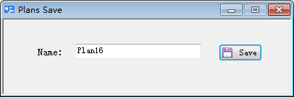

2、Read Plan: enter the "Read Plan" interface. Click "plan" in the menu bar of the software main interface, and click "Read plan" in the drop-down menu, and the "Read plan" window pops up, as shown in the following figure:

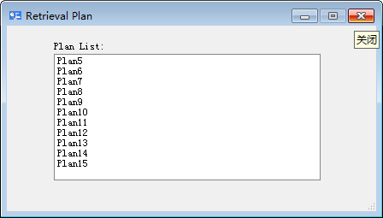

Double - click on the selected Plan to read Plan. Right mouse button deletion, renaming plan, as shown in the picture:

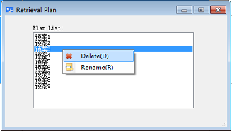

3、Polling Plan：Enter the "Polling Plan" interface. Click "plan" in the main menu bar of the software, click "Polling plan" in the drop-down menu, and the "Polling plan" window will pop up, as shown in the figure.
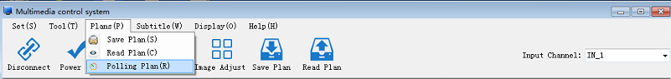

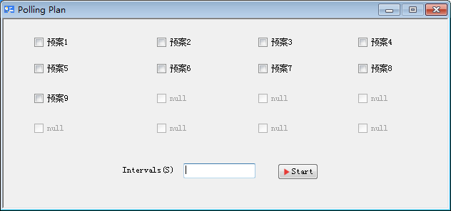
Polling Plan interface
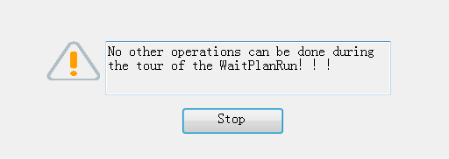
The Polling Plan interface

4.4.Subtitle
Subtitle function includes subtitle setting and subtitle synchronize.
1、Subtitle Setting：Enter the "subtitle setting" interface. Click "subtitle" in the menu bar of the software main interface, and click "subtitle setting" in the drop-down menu, and the "subtitle setting" window will appear, as shown in the figure:
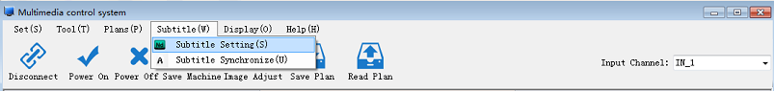

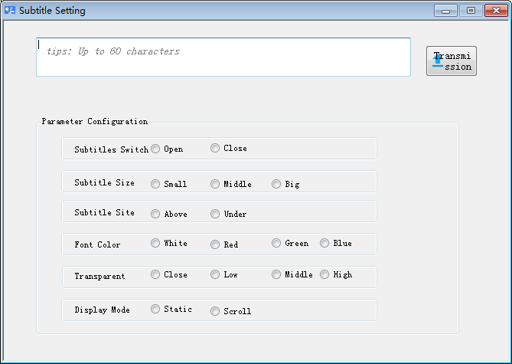

2、Subtitle Synchronize：Click "subtitle" in the menu bar of the software main interface, and click "subtitle synchronize" in the drop-down menu, and you can use the function of subtitle synchronize.
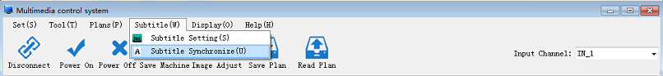

4.5.Display
Display function:Including HDMI type DVD Mode, PC Mode, Display Mode Image Display, Text Display, Query Display, Information Display, Clear Query. This feature is only available after "Open Connect".
1、HDMI Types: HDMI Types include DVD Mode and PC Mode, and use HDMI Types in two modes, as shown in the figure:
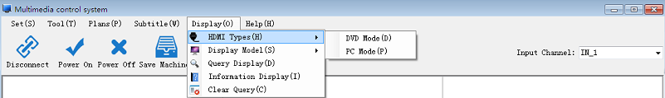

2、Display Model: Display Model includes Image Display and Text Display, and click two Display modes of Display Model, as shown in the figure:
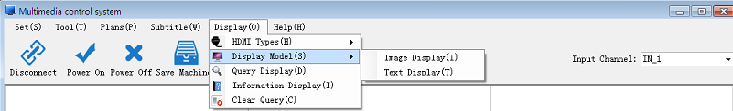

3、Query Display，Clear Query：Click "query display" and "clear query".Click on the "query display", if there is data back, will be shown in the cell running time of the screen, the reference temperature, running state, if no data is returned, is in the running state of the screen display in the cell is close and click on the "clear query" will erase the data shown in the cell.
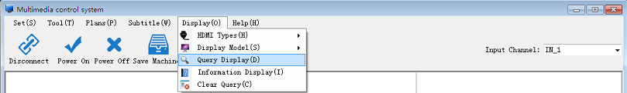

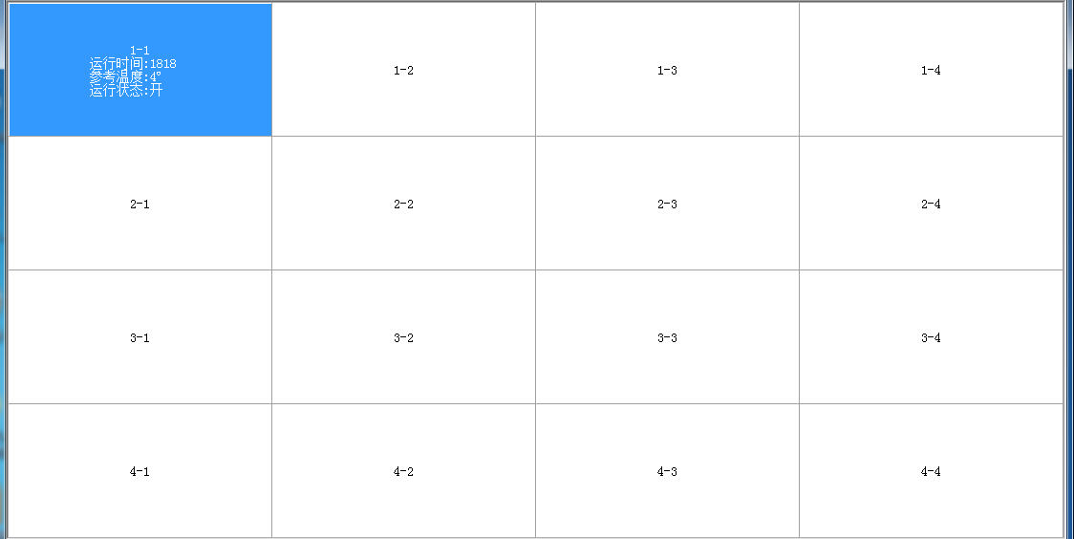
The data returns the cell display.

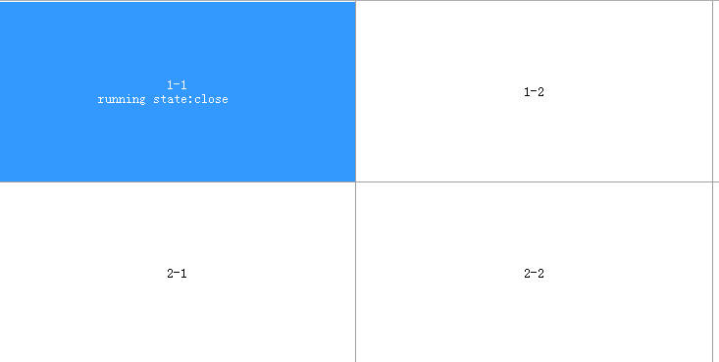
No display of data returned.

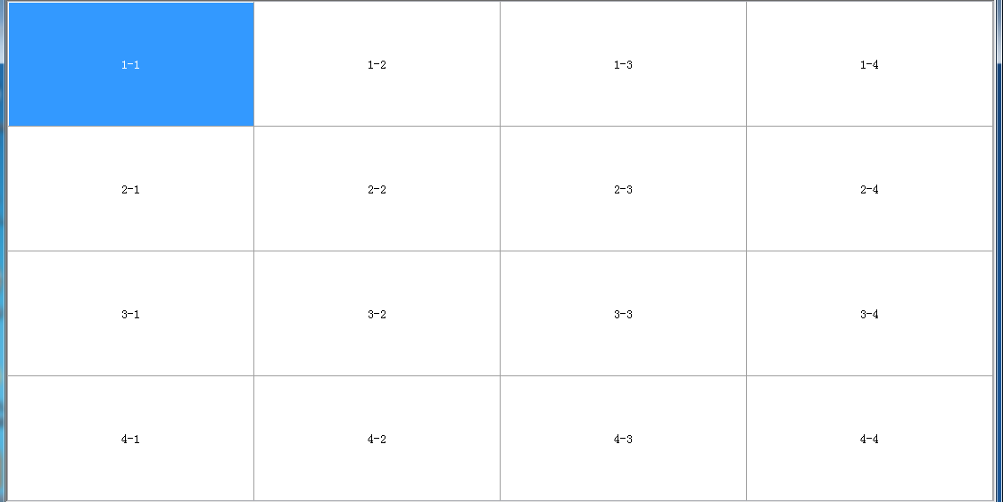
The removed cells are displayed.

4、Information Display ：Click "information display" as shown below:
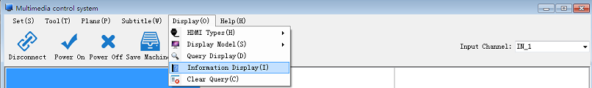

4.6.Help
5.6.1.User Registration
Click "Help" in the main interface of the software, click "user registration" in the drop down menu, and the "user registration" window will appear.

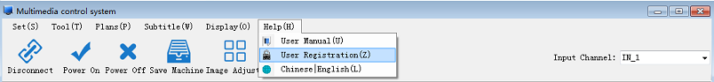
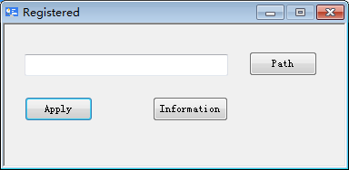
User registration window.

5.Toolbar
The toolbar function interface is divided into the general user toolbar interface and the super user toolbar interface. This paper mainly introduces the four functions of open connect, power on, power off, input channel, save machine, image adjustment, save plan and read plan.
Common user toolbar interface
Super user toolbar interface

5.1Connect
Before opening the connection, set up the communication and matrix. Click "open connect" on the connection device, Disconnect the device connection and click "Disconnect", as shown in the figure:

5.2 Power switch
The Power On function is to turn On the screen, select the screen, and then click "Power On".The "Power Off" function is to turn Off the screen, select the screen first, and then click "Power Off".Note that only when the connection is opened can "Power On" and "Power Off" operate, as shown in the figure:
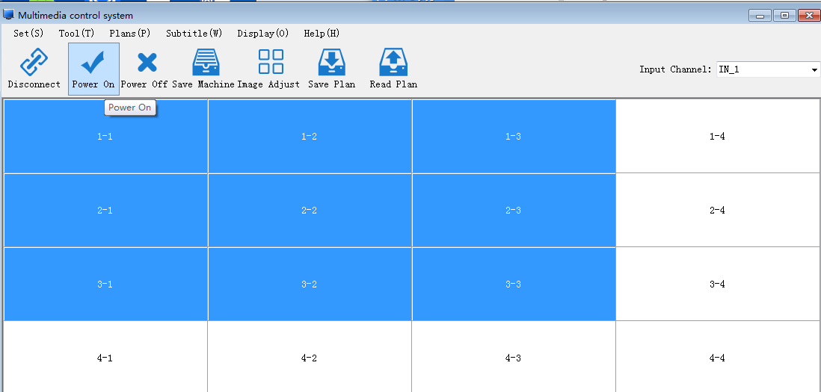

5.3 Input Channel
Select the input channel, and click the right mouse button to change the input channel name. As shown in the figure:
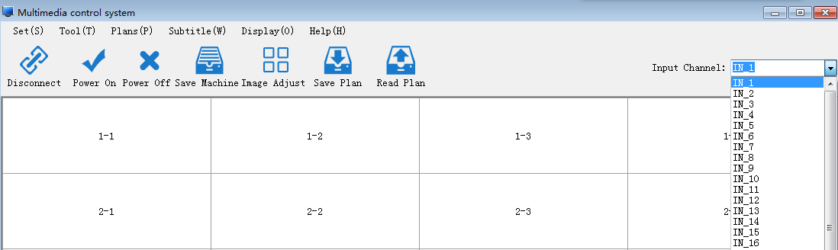

6.Operating area
After a series of Settings, it can be spliced. Operation mode: select a certain number of cells, and click the right mouse button, and there are four kinds of signal sources (HDMI, DVI, VGA, VIDEO) and single display in the menu with right mouse button, as shown in the figure:
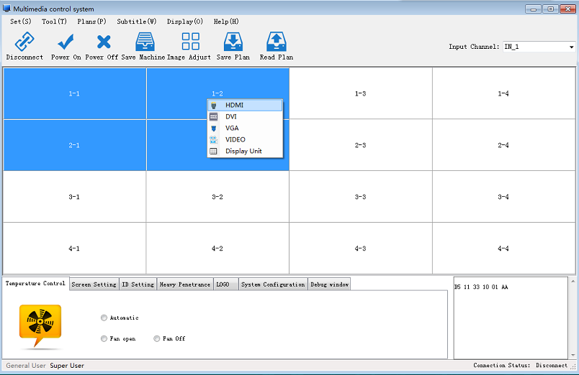

Special additional functional areas
This section describes some of the features of the special additional section, including the following information: additional functionality, command display.

Additional features

7.1.1.Temperature Control
Temperature Fan control, the default is "Automatic" : in addition, Fan open, Fan off, mode can be selected by customers, as shown in the figure:

7.1.2.Screen Setting
Test items there were about an LVDS signal output screen splicing box set (convenient screen test) baking machine mode switch, kao machine model must be opened only in the case of no signal, function is: red, green, blue, white and black color such as flashing, can do not need to shut down. Configuration screen parameter, can increase the screen parameter type and flip. The screen switch will be black screen restart, please note. Switching over can be used normally.
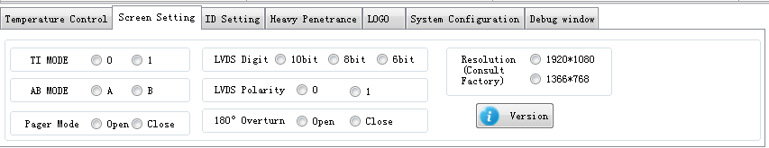

7.1.3.ID Setting
ID identification code setting, first can generate the identification code, then based on the generated identification code to set the line address.

First login to the super user, enter password 123321 -- select ID Settings -- click "Produce Identifier", all screens will display similar prompts, as shown below:
Identifier 2
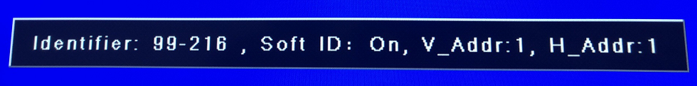
Columns
Rows
Rows
Identifier 1

Input the prompt message of the screen to the corresponding location, as shown in the figure below:
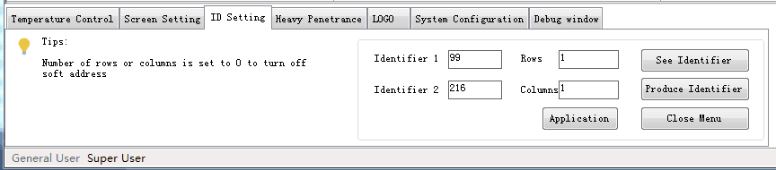

Click "Application", and the screen display information is as shown below:

All screens are set ID in this way, and the completion status is shown as below:
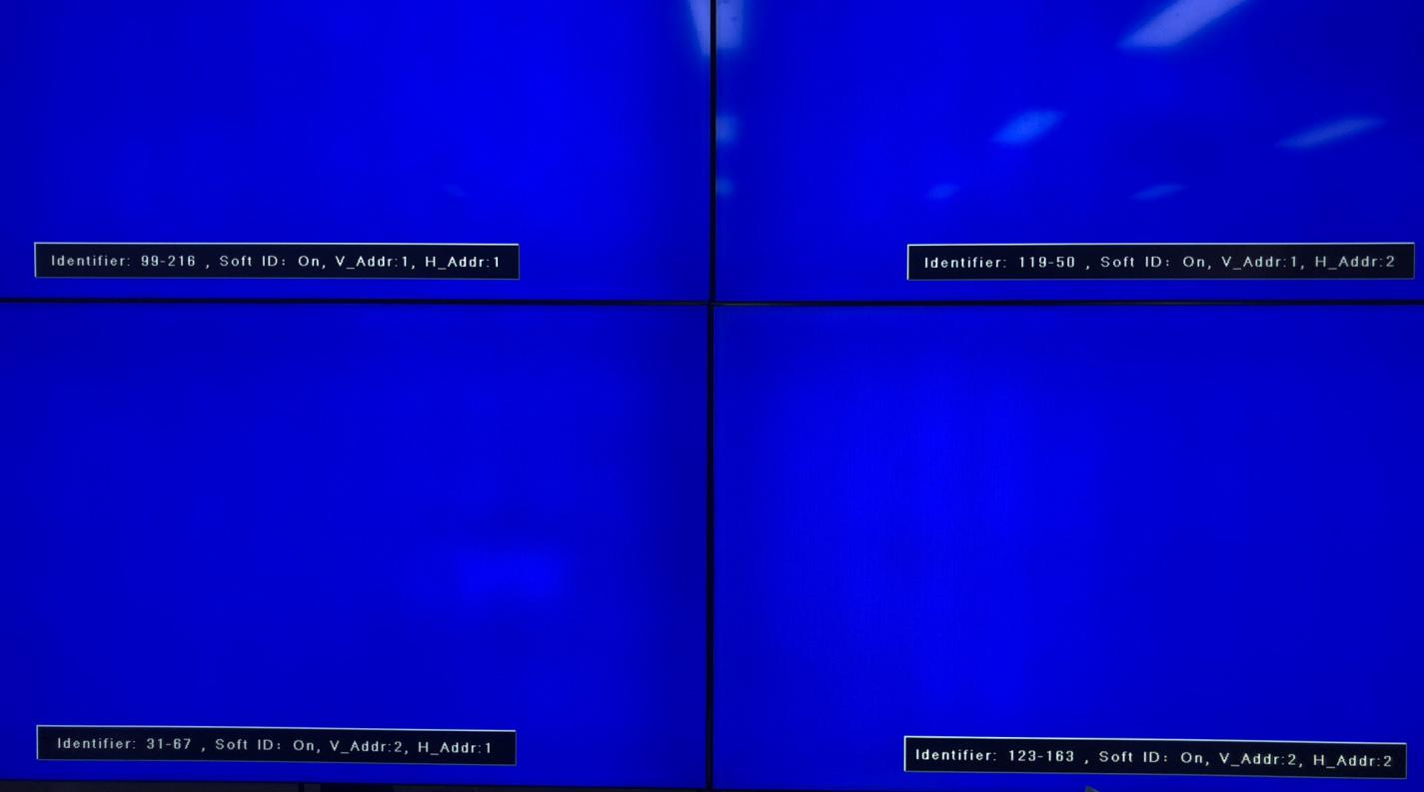
After setting, please select all screens, click on the machine to save, and on all screens, the word "save" will be displayed. Please do not do any other operation before the reminder is gone!

7.1.4.Heavy Penetrance
Adjust the edge image processing such as CVBS, the screen display size adjustment, the adjustment can be restored.
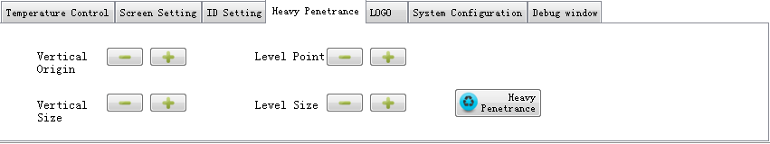

7.1.5.boot LOGO stitching
Whether the LOGO is needed to set up the machine, and whether the LOGO is stitching off or stitching open, the LOGO is displayed in the cell when the device is off. No signal LOGO is selected to display mode without the signal. If the LOGO is selected, then stitching off or stitching open can be selected.
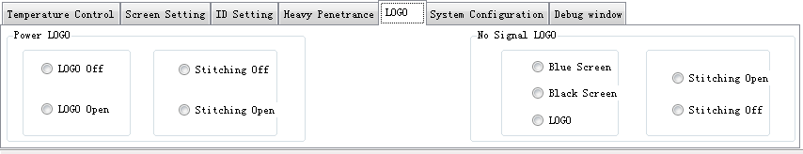

7.1.6.System Configuration
1、The total reset interface, the password is cjfw, this reset will be reset to all Settings except (limited time and preplan), including soft ID will be reset.
2、In the case of a u-disk connection, there is a corresponding bin file, which can be upgraded through a usb stick to the designated large screen splicing box.

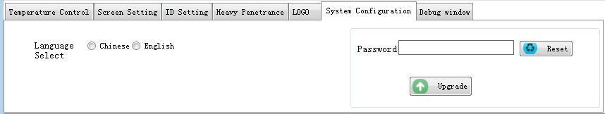

7.1.7.Debug window
The sent instructions display can be sent by (string mode, Hex mode).
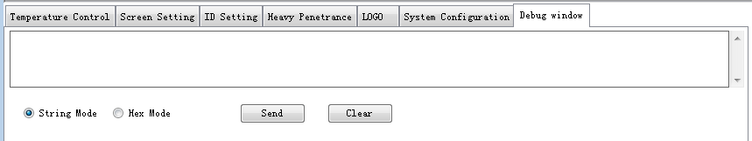

7.2 Command display
The command display box is in the lower right corner of the main interface, and the command is displayed in the display box.
