QS36/QS108 Transmitter Guide
Content
1. Product Introduction 2
2. Product Overview 2
USB Transmitter 2
3-in-1 Transmitter 3
3. Transmitter User Guide 4
USB Transmitter Casting 4
TYPE-C Transmitter Casting 6
HDMI Transmitter Casting 6
4. Question& Answer 7
Casting Problem: 7
1. No response when connecting USB Transmitter to laptop(USB casting mode) 7
2. USB transmitter does not detect the receiver 8
3. USB Transmitter Pairing 9
4. USB Transmitter upgrading 9
5. How to check the USB Transmitter version 9
6. How to Pair the transmitter with computers 10

Product Introduction
Quickshare transmitter is a transmitting device which works with the Quickshare receiver devices to transmit the video source, such as notebook computer, Laptops, mobile phone and other equipment, to the Quickshare receiver for display.
Quickshare receiver include Quickshare Mirroring software which built-in Meeting Flipper Boards and also series of Quickshare receiver boxes. Hereby we mainly introduce the basic use of Quickshare Transmitters.

Product Overview

USB Transmitter

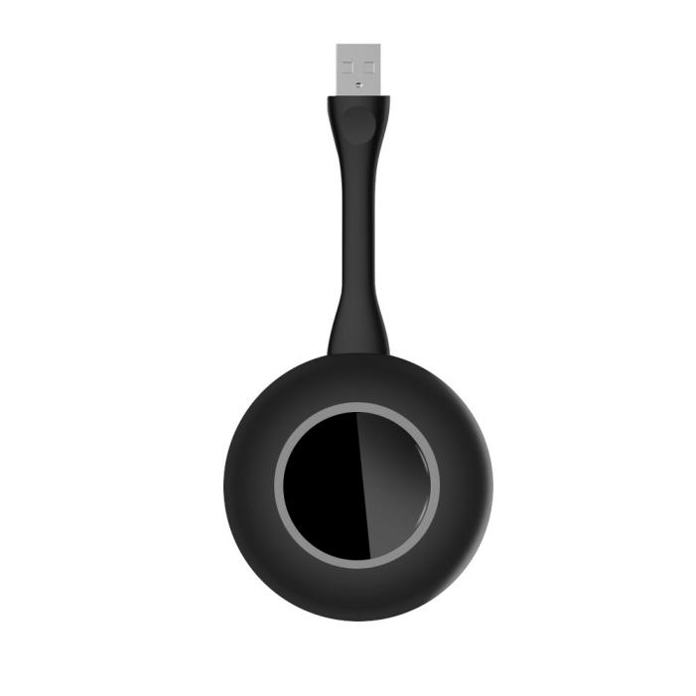
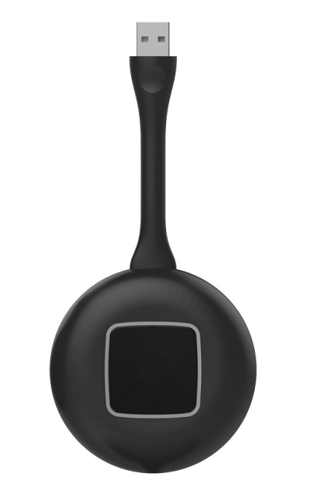

3-in-1 Transmitter
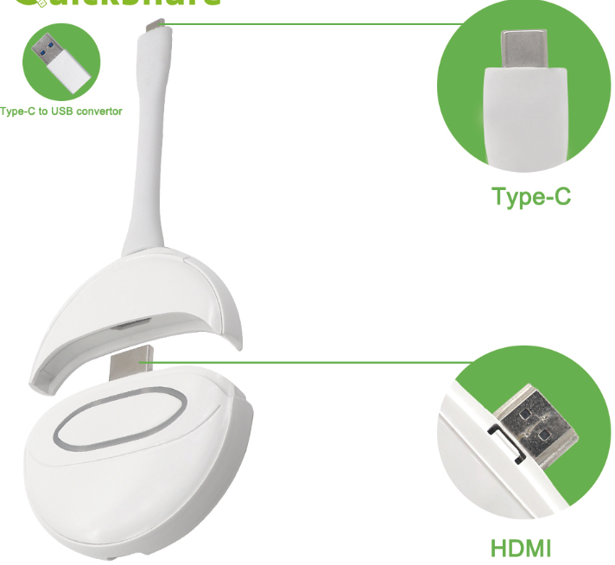
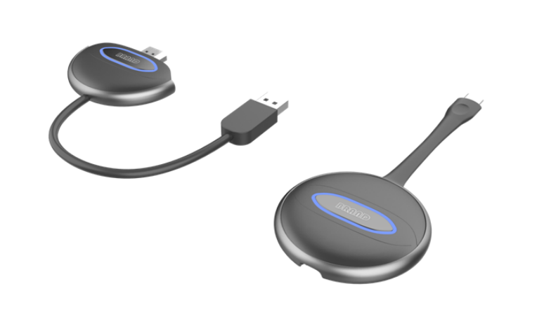

Transmitter User Guide
QS108（3-in-1 transmitter） | Support TYPE-C/HDMI/USB devices casting
QS36（USB transmitter） | Support USB device casting

USB Transmitter Casting
QS36 is default USB port casting, QS108 is default Type-C port casting, or USB convert to Type-C or USB cable for USB port casting.
- Connect USB transmitter to USB port of the computer for transmission (when the user uses the transmitter of computer first time, you should do steps as below: go to the computer - removable storage - double click CD drive: usbdisplay), and then the transmission application will run automatically. Note that the win10 system need turn off the firewall (Windows Defender). The driver is as below:
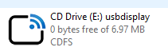

- After the transmitter inserting, it will start automatically. The flashing light indicates that the transmitter is starting,while waiting for about 8-10s. When the transmitter light is always on, the bottom right corner of the computer desktop will also pop up: Press the button to share the screen, as shown in the following photo; click the transmitter to mirror the screen.
(In some computer system, due to the reason of anti-virus software interception, it is not used for the first time, and the transmitter fails to run automatically, so it is necessary to execute the main program APP\USBDISPLAY.EXE in the usbdisplay drive.)
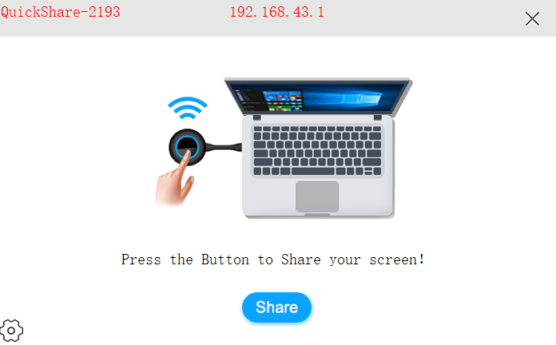
- In addition, a mirroring icon will display in the status bar in the lower right corner of the desktop,Right click the icon and select options. You can choose to expand the screen, transmit sound, auto drop screen, mouse acceleration and coding algorithm.
- When the transmitter is connected to the box successfully, a round green button will appear in the upper left corner, and the number displayed represents the number of transmitters connected to the box. Click to expand the display host mode, and repeatedly click the device in the projection screen or click the connected device to start transmission, as shown in the following photo:

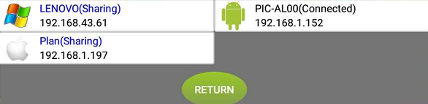

TYPE-C Transmitter Casting
- QS108 transmitter is connected to the type C port of computer for casting. The flashing light of the transmitter indicates that it is starting. Waiting for around 10 seconds, when the light of the transmitter is always on, click the button for casting.
- Some laptops have Type-C port, but this Type-C port doesn’t have Video output, actually this Type-C port is USB signal. Under this condition, the transmitter is under USB transmission mode, pls follow up the above USB casting.
- Note: After the device is pulled out, the type C transmitter need wait for 3 seconds to insert the device for screen casting, otherwise it will be unable to connect.
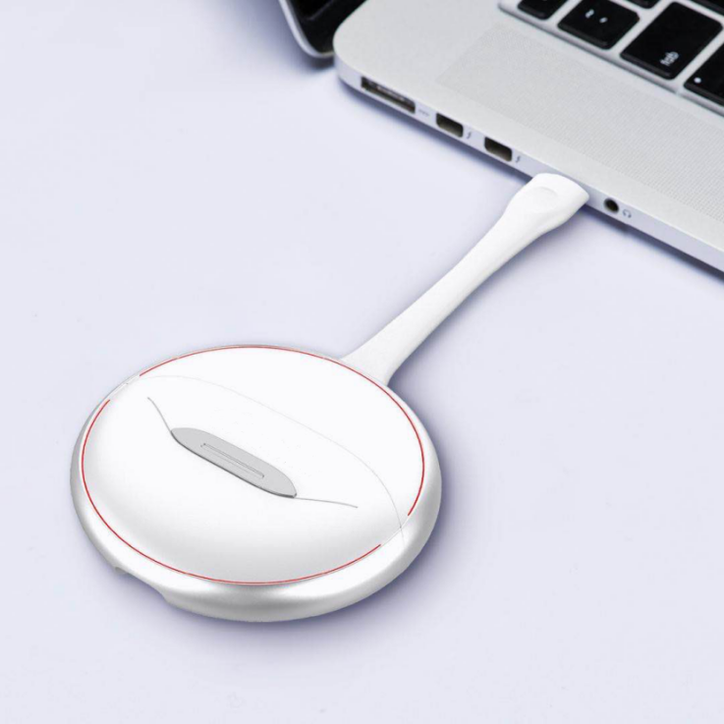

HDMI Transmitter Casting
Pull out QS108 transmitter separately
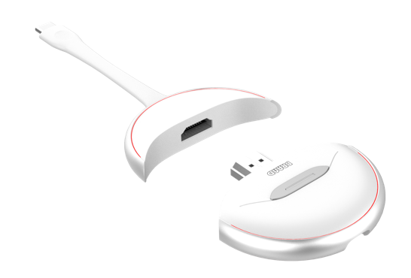
Meanwhile plug the USB cable into it as below photo:
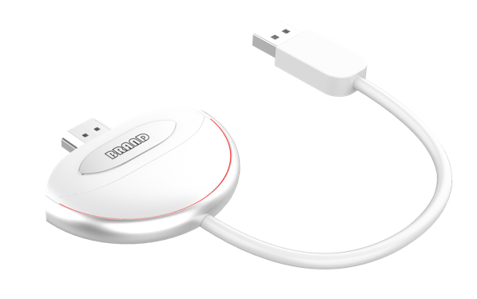
Plug the HDMI of QS108 into the HDMI port of the computer, If the light of QS108 is not on, it indicates that the power supply is insufficient. It is necessary to plug the USB cable on the QS108 into the USB port of the computer for power supply. At this time, the flashing light of the transmitter indicates that it’s starting. Waiting for around 10 seconds, when the light of the transmitter is always on, click the button to switch on the screen. Only when the USB cable is inserted into the computer, and then can touch back.

Question& Answer

Casting Problem:

No response when connecting USB Transmitter to laptop(USB casting mode)
When connecting the USB Transmitter to laptop, but there is no response and as below photo:
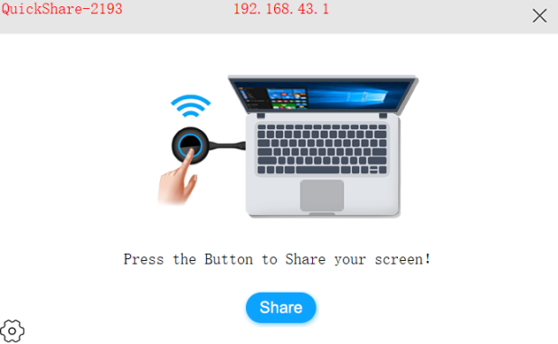
You need go to “My computer”to find USBDisplay in CD drive,double click the USBDisplay and mirror system will run automatically. (Please note the Win10 system should close the Windows Defender) The CD Driver will show as below:
If there is no response when double click the drive, Please use the mouse right button to double click the system which is end of “exe” programme

USB transmitter does not detect the receiver

The computer is connected to the USB transmitter, and the following interface appears on the computer screen. Please check whether the USB transmitter has been paired with the box. If the box backup has been reset or the hotspot and password have been changed, you need pair again for transmitting.

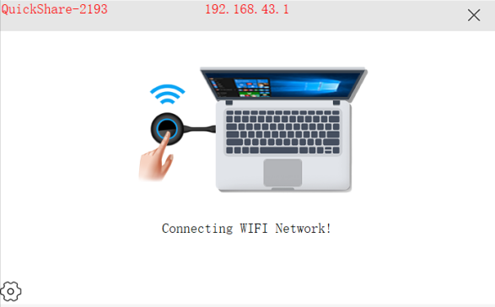

USB Transmitter Pairing
Connect the transmitter to the USB port of box to automatically pair. And the receiver box will be as below:
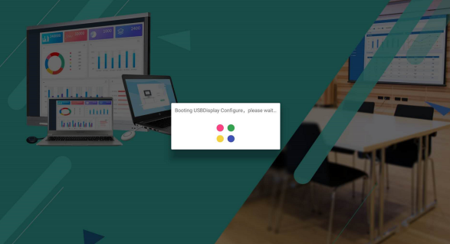
After pairing successfully, the photo will be as below:
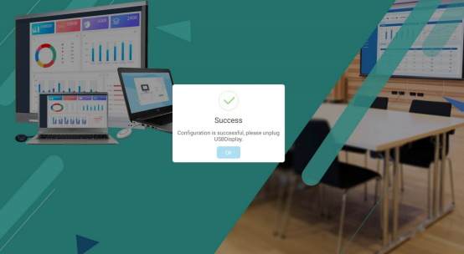

USB Transmitter upgrading
When the host device is connected to the Internet, the box will automatically updated according to the server update. If USB Transmitter pop up the message to upgrade, Please click to upgrade. And then, you need insert the USB button into the USB port of box for upgrading and pairing to synchronize the version. Please don’t plug the USB Transmitter during upgrading.
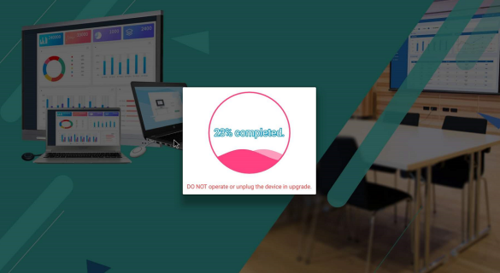
After upgrading 100%,the interface will show upgrade success, and then pair with the device. After pairing, you can connect to Laptop for casting.
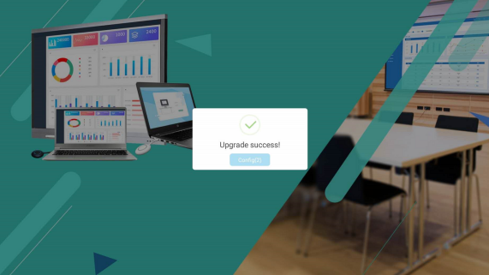

How to check the USB Transmitter version
As shown in below photo, click the setting in the lower left corner of the USB Transmitter ,open” ABOUT” to check the current version.
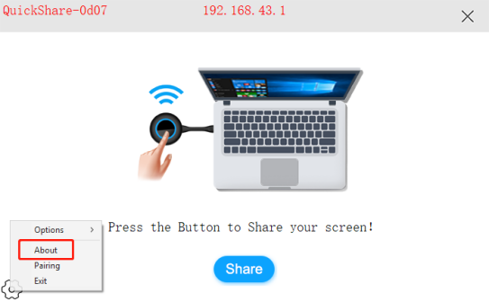

How to Pair the transmitter with computers
The transmitter can be also configured with a Windows computer, which is mainly used when it is not convenient to insert the transmitter into the host devices.

As shown in below photo, click the settings in the lower left corner of the transmitter to open the pairing. The pairing information is consistent with the box information. Click pairing to prompt that the pairing is successful after 3S.
