Functional features

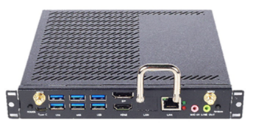

* Supports Comet lake-H 10th Gen Intel® Core™ i3 i5 i7 processors
* The display has HDMI/DP interface and supports The display has
* SSD mSATA+ SATA HDD，dual channel
* Compatible with OPS-C full range of product upgrades, switching
* Supports dual-channel SO-DIMM DDR4 memory and M.2 SSD storage
* BIOS supports AMI 64Mbit diskless boot, power on, timed boot
* Support JAE 80Pin connection interface
* Hardware support one-key restore system function

Specification parameters

