Intech Infrared Touch Panel

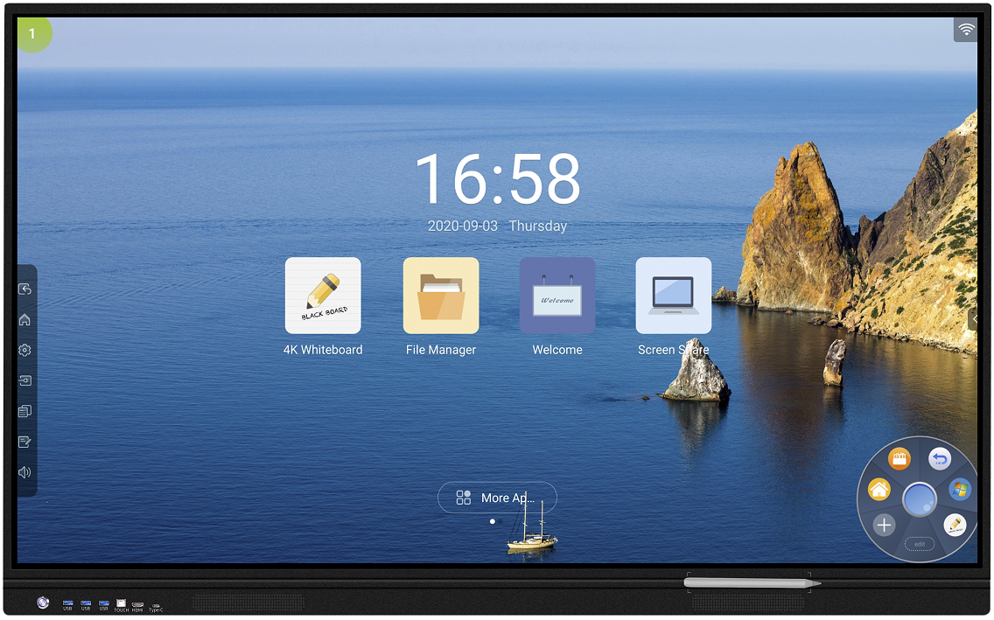

1. Product Features
(1). System:
- Support Android 8.0 operation system and 4K Ultra HD screen;
- 2xCA73+2xCA53 CPU, quad-core, 64bit, 1.5GHz;
(2). Appearance & Touch Functions:
- 12mm ultra-slim frame;
- Support high-speed IR 20 points touch, ±1 mm accuracy, 1.0 mm touch height, front detachable touch module;
- It has OPS port supporting dual systems; and there are three USB ports for computer and Android system use.
- Front Type-C connector for various functions, including HD video transmission, USB pass-through, touch pass-through, network pass-through of the external devices, 5V/1A power supply;
- Video transmission: supports 4K@60Hz, mirror the computer/mobile phone’s screen onto the touch panel
- Network pass-through: it supports to
- USB pass-through: The external devices can read the USB device of the touch panel with no need to repeated plug and unplug.
- Touch pass-through: You can control the external devices that connect through the Type-C from the touch panel;
- Power supply (5V/1A): It can provide power for the external device, thus, the meeting would not be interrupted by the outage of the devices.
- Front magnetic pen slot to stick stylus pen within easy reach.
- It supports use an antenna to connect the Android system, meanwhile, the OPS device can surf the internet.
- When connecting external USB, the system enters the safe mode to safeguard the files. Users need to input the password to unlock it.
(3). Whiteboard Writing Function:
- 4K resolution with superfine writing experience;
- Powerful software supports single and multi-point touch; precisely recognizes the force you apply onto the screen; supports insert pictures, add page and gesture recognition for remove, zoom in/out, roam; supports annotation and share documents via QR code.
- Support zoom in/out, undo and redo unlimitedly
- Anti-glare explosion-proof tempered glass, Mohs grade 7 hardness for safety and better writing experience.
(4). Meeting & Training:
- Built-in WPS, welcome page, and so on office software;
- Built-in 2.4/5G network card, support WIFI and hotspot simultaneously
- Wireless sharing with multi-users, supporting reverse screen mirror (control your touch panel from your mobile devices), remote snapshot, video, music, document share, screen shoot, etc.
- Automated recognize the external input signal source and easily switch the screen.
(5). Business Solution:
- High definition image process: image motion compensation, colors enhancement process, peer-to-peer image display;
- Three fingers to move the floating menu, five fingers to touch the screen entering sleep mode;
- Customize the welcome page, theme, and background; auto classify the local players to cater to the different requirements;
- It supports use sidebar buttons or gestures to call out the guichet menu: voting system, timer, screenshot, child locker, recorder, camera, touch function, smart eye-care function, touch controlling switch, etc.
- Compatible with the external information releasing APK software to remote present video, image, scroll titles, enterprise/school’s introduction, etc.

2. Product Parameter
(1). Specifications
Item | Model | TS65 | TS75 | TS86 | TS98
Technical | Size | 65" | 75” | 86” | 98”
 | Overall Size | 1479.9*923.6*106.1 mm | 1699.2*1038.1*106.5 mm | 1946*1181.8*113.15 mm | 2227.4*1345.8*122 mm
 | Packing Size | 1600*1025*215 mm | 1870*1150*220 mm | 2110*1315*240 mm | 2500*1630*440 mm
 | G.W/N.W | 52/43 KG±1.5KG | 69/58 KG±1.5KG | 110/92.7 KG±1.5KG | 197/139 KG±1.5KG
Screen | Screen Manufacturer | TCL CSOT
 | Backlight Type | D-LED
 | Resolution | 3840*2160
 | Brightness | 550cd/m²
 | Contrast Ratio | 6500:1 | 6500:1 | 6500:1 | 6500:1
 | Response Time | 6ms
 | Dot Pitch | 0.124*0.372 mm (H*V) | 0.4298*0.4298 mm (H*V) | 0.4875*0.48758 mm (H*V) | 0.5622*0.5622 mm (H*V)
 | Refresh Rate | 60 Hz
 | View Angle | 178°(H) / 178°(V)
 | Saturation (x% NTSC) | 72 %
 | Display Area | 1428.48 (H)*803.52 (V) mm | 1650.24 (H)*928.26 (V) mm | 1872 (H)*1053 (V) mm | 2158.85 (H)*1214.35 (V) mm
 | Colors | 1.07B(8bit)
 | Screen Lifespan | 50,000 hrs
Mainboard | Chipset | MSD8386
OS | Android Version | Android 8.0
 | CPU | CA53*2+CA73*2
 | CPU Base Frequency | 1.5 GHz
 | # of Cores | Quad-core
 | GPU | G51MP2
 | RAM | 3 GB DDR4
 | ROM | 32 GB Standard
Power  Power | Input Voltage | 100 V ~ 240 V/AC, 50/60 Hz
 | Max Consumption (without OPS) | ≤220W | ≤300W | ≤350W | ≤450W
 | OPS Power Input | 19V(DC)/5A
 | Standby Consumption | <0.5W
 | Power Input Port (AC) | *1
TV System | TV | ATV (PAL,SECAM)
 |  | DTV (DTMB)
Function | Speaker | 8Ω/20W*2 | 8Ω/20W*2 | 8Ω/20W*2 | 8Ω/20W*2
 | Power On/Off | *1
TV System | Video Decoding | Image denoising, image self-adaptive filtering, etc.
 | Channel | 200
 | Stereo Amplifier System | Yes
I/O Ports | LAN | *2
 | VGA IN | *1
 | PC-AUDIO IN | *1
 | YPBPR | *1
 | AV IN | *1
 | AV OUT | *1
 | Earphone OUT | *1
 | RF-IN | *1
 | SPDIF | *1
 | HDMI IN | *3 (1 front)
 | Touch | *2 (1 front)
 | Type-c | *1 (front)
 | RS-232 | *1
 | USB2.0 | *5 (3 front dual-channel USB2.0)
Environment | Working TEMP | 0℃ ~ 40℃
 | Storage TEMP | -10℃ ~ 60℃
 | Working Humidity | 20% ~ 80%
 | Storage Humidity | 10% ~ 60%
 | Recommended Max Usage Time | 18Hours*7days
Structure | VESA Hole | 4-M8 screw hole 400mm*200mm
 | Shell Material | aluminum alloy/metal plate
 | Shell Color | black
Language | OSD Menu | 10 languages (English, Chinese, etc.)
Packing List | remote control*1 (no battery),1.5m power cable*1,normal pen*1 WIFI antenna*3wall mount bracket*1 (include screws), user manual*1, usb a-b *1,usb a-a*1,HDMI *1 ,POINTER *1

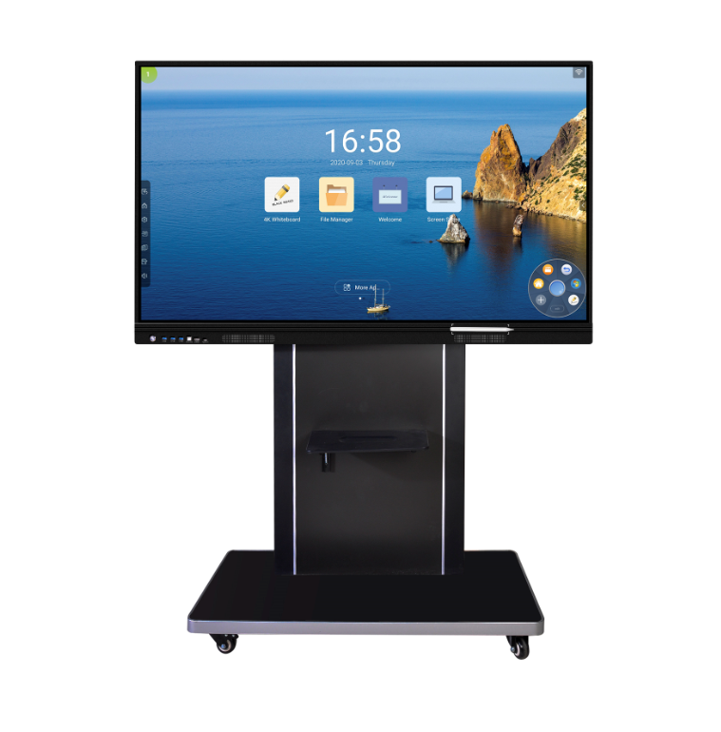
(2). Product Image

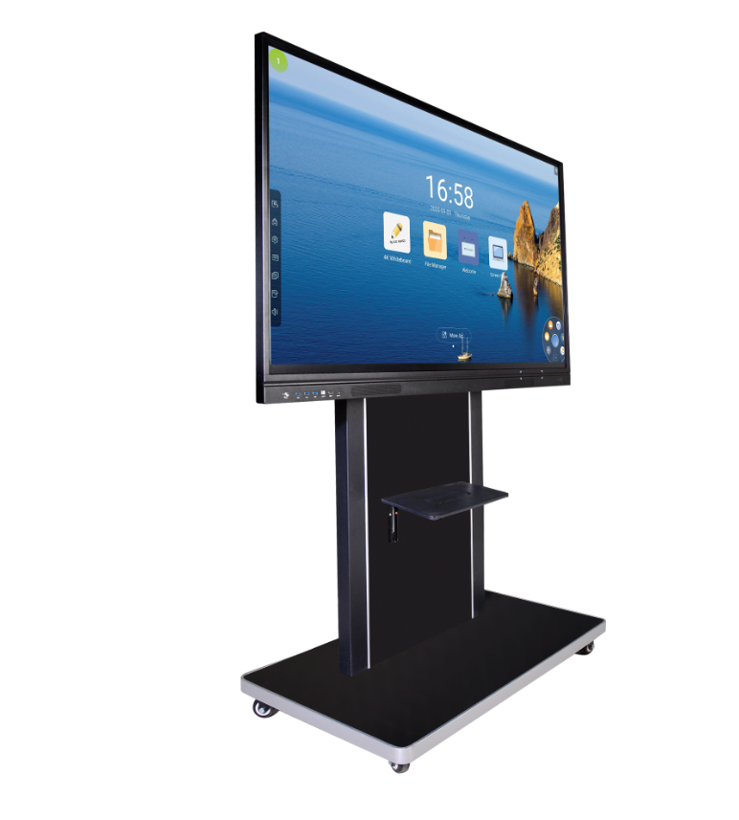

3. Touch Writing System
(1). Features
- Infrared touch frame
- 32768*32768 resolution
- Support 20 points touch
- Plug and play
(2). Parameter
Touch parameter | Touch Technology | Infrared
 | Glass | 4mm anti-glare tempered glass
 | Response Time | ≤6ms
 | Touch Accuracy | ±1mm
 | Touch Diameter | ≥3mm
 | Input Method | finger/stylus pen
 | Theoretical Touch Times | unlimited
Interface | USB 2.0 full speed
Voltage | DC+5V±6%
Power Consumption | ≤2W

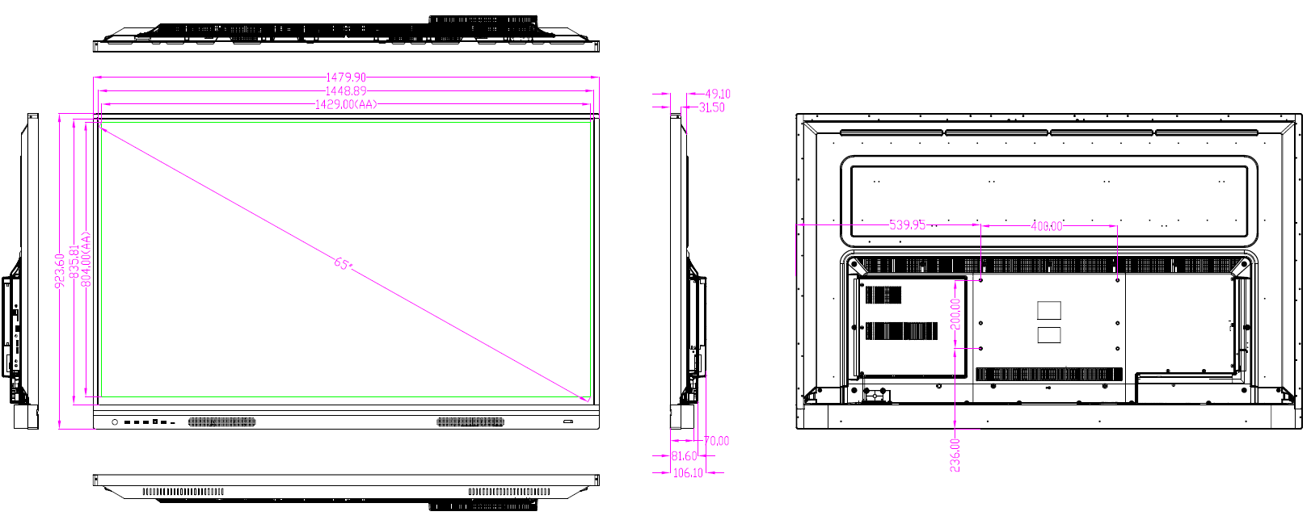
4. Product Diagram (wall mount hole 400*200)

