VIDEO WALL

MH5517/600L LCD Video wall（Sheet Metal）
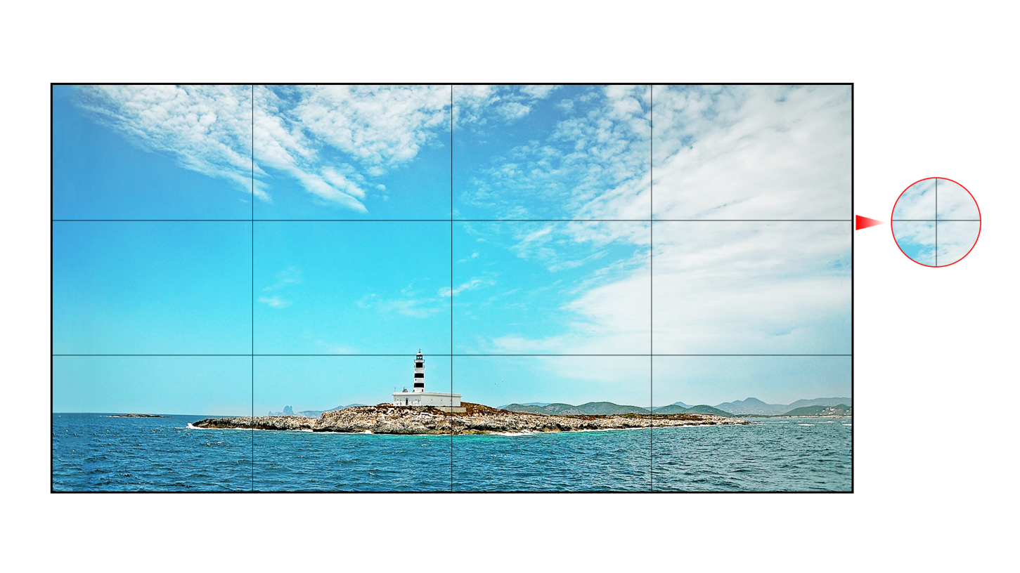

Ultra narrow beze
1.8mm

- Support upgrade online by USB
- Support non-stop running time up to 7*24
- Built-in software, supporting arbitrary combination of images
- Support Rs232 connect in cycle and remote control
- Support customize the boot screen when it’s no signal
- Support online subtitles, such as urgent subtitle, set-time broadcasting, Image scrolling, etc.
- Support change logo online

Parameters

Specification | Type | Parameters
Panel | LCD size | 54.64"
 | Panel type | LD550DUN-THB8
 | Panel check standard | A grade
 | Light source | LED backlight
 | Resolution | 1920 x 1080 pixels
 | Brightness | 600 cd/m²(typ.)
 | Contrast ration | 1400:1(typ.)
 | Pixel pitch | 0.630×0.630 mm
 | Frequency | 60Hz
 | Viewing angle | 178°(H)/178°(V)
 | Life span | 50,000hrs(min.)
 | Color saturability | 72%
 | Display area | 1209.6(H)mm x 680.4(V)mm
 | Display colors | 1.06B
Project | Scalar | MSTAR V56（M56W）
Power | Power | 100~240V,50~60Hz
 | Maximum power consumption | ＜170W
 | Standby power consumption | ＜0.5W
Environment | Working temperature | 0℃～40℃
 | Storage temperature | -20℃～60℃
 | Working humidity | 10%～90%RH Non-condensing
 | Storage humidity | 20%～85%RH Non-condensing
 | Display mode | Standard、soft、User、Beautiful
 | Normal use time | 24 hours
Input Interface | USB-IN | 1
 | HDMI-IN | 1
 | DVI-IN | 1
 | VGA-IN | 1
 | CVBS-IN | 1
 | RS232-IN | 1
 | USB-IN | 1
Output Interface | RS232 OUT | 2
Structure | Net weight | 26±1kg
 | Gross weight | 54±1kg(two in one)
 | Bare dimension | 1211.54 x 682.34 x 131.95 mm
 | Packing dimension | 1345 x 400 x 835mm(two in one carton)
 | Shell material | Metal
 | Shell color | Black
 | Bezel | 1.8mm
 | Wall Bracing | 4-M6 screws, 580 x460mm
Language | OSD | En/CH
Accessory | Remoter | 1
 | Power cord | 1
 | Certificate | 1
 | Rs232 Connect Line | 1
 | RJ45 to RS232 interface socket | 1
 | Remote receiver | 1
 | Battery | 1(pair)
Function | Support 8 bits dual LVDS (1920 * 1080) HD display
 | Using 3-D digital comb filter
 | True color OSD, humanized operation menu
 | Adopt MSTAR ace-5 automatic color and image enhancement engine to improve image contrast ratio, detail, skin color, edge, etc.
 | Perfect factory setting mode
 | Adopt 3-D noise reduction technology
 | Built-in splicing software to splice into a large screen
 | Support USB2.0 software upgrade
 | Using programmable 12 bit RGB gamma correction technology

VIDEO WALL

Product Image
（Photo, reference only, actual object depends on Dimension Drawling）
Interface
(The picture is for reference only, subject to the real object)

VIDEO WALL

Six view
