>>> H310-I5-8500+8G+256G Catalog <<<
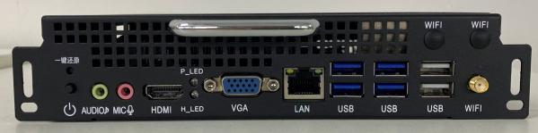  Photo | Main Spec:
 | 1. Front VGA+HDMI port, support 4K.
 | 2. WIFI antenna.
 | 3. Front and rear JAE connector for optional.
 | 4. Support Intel® Core™ Processor and Intel® Celeron® Processor G Series.
Processor | Chip | Intel® H310 Express
 | CPU | 8th Intel® Core™ i5-8500
 | Performance Spec. | # of Cores: 6 # of Threads: 6 Processor Base Frequency: 3.0GHz
Memory | Technology | 1 x SODIMMs DDR4
 | Memory | DDR4-8G
Display | Front Output | DP-Max.3840 x 1920
 |  | VGA-Max.1920 x 1080
 | JAE Connector | HDMI-Max. 3840 x 1920
Processor  Graphics | Model | Intel® HD Graphics 630
 | Max. Memory | 64G
 | Base Frequency | 350 MHz
 | Max. Dynamic Frequency | 1.05 GHz
Hard Disk | SSD | 256G
Network Adaptor-  Dual Band 5G | Interface | PCIE
 | Support | Dual Band 2.4g/5g
 |  | Gigabit LAN Controller
I/O Port | JAE Connector | 1(JAE TX25 80-PIN)
 | DP | DP-Max.3840 x 1920 (Optional)
 | VGA | VGA-Max.1920X1080
 | HDMI | HDMI-Max.3840 x 1920
 | LAN | RJ45. Gigabit
 | USB | 4 x USB3.0 & 2 x USB2.0
 | AUDIO | 1 x AUDIO OUT + 1 x MIC IN
Extension Port | Mini-PCLe  (built-in) | 1 x Mini-Pcie
 |  | 1 x Msata
Power | Input voltage | DC-IN 12~19V
Physical | Size | 180 x 195 x 42 mm
 | Material | Metal
Heat Dissipation | Dissipation | Copper pipe dual-ball fan for cooling and temperature control
Environment | Temperature | 0 - 40℃
 | Humidity | 95% @40℃(Non-condensing)
Software Development Kit | OS | Windows® 7.0, Windows® 8.1, Windows® 10, Linux

