Ultra-thin LCD & Microphone Lifting Unit

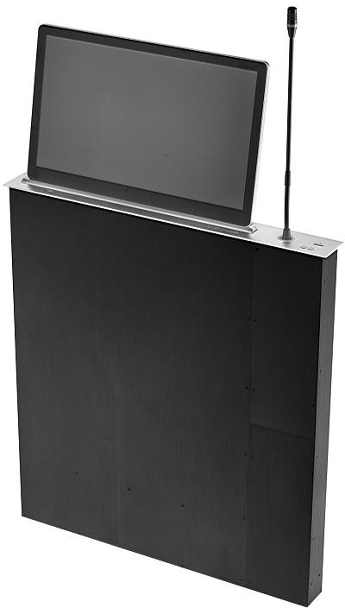

Please carefully read the use manual before using the system VI

File Instruction
Please carefully read the manual before using the product and appropriately keep for reference in the future. Please carefully read the Guidelines for Safe Operation. Notes: Danger. Attention.
This manual is only for guiding the user operation rather than for repair service. The expiry date of the aforementioned functions is December 30, 2020. If there is any change in the functions or relevant parameters after the expiry date, additional notes will be provided without further notice. If you need more information, please inquire the distributors.
All the copyrights reserved. Without the written permission of our company, all the units or individuals shall not arbitrarily excerpt or copy partial or all the contents of this file or spread in any form.
In view of trademark statement, all the other trademarks or registered trademarks mentioned in this file shall be owned by their owners, respectively.
The pictures of the products in this manual are for reference only. Please refer to the physical objects.

Machine name: Ultra-thin LCD & Microphone Lifting Unit

Guidelines for Safe Operation
In order to guarantee the reliable use of devices and staff safety, please abide by the following issues in installation, use and maintenance:

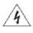 Danger
- There are live parts in the device, without permission, non-professionals shall not dismantle the device in case of electric shock.
- Please do not dismantle the device when electrified or during operation in case of electric shock.
- Please do not operate with wet hands in case of electric shock.
- It is forbidden to place the product in the environments with flammables, explosive gases or heat sources for use。
Attention
- It is forbidden to spray any corrosive chemicals or liquids on or near the device.
- Please maintain the good ventilation of working environment and do not block the cooling hole in convenience of in-time discharge of heat emitted by the device in operating and in case of device damage due to excessive high temperature.
- Please do not place the device on the unstable platforms to avoid falling of device that leads to damages.
- It is suggested to use the appropriate packaging or use the original packaging during the transportation process to avoid the device damages due to sharp vibration.
- Please do not squeeze the power supply wires and device with heavy objects.
- A grounded power supply must be used for the device.
- Please do not repair arbitrarily in case of aggravation of the device’s damage degree.
- Please be cautious of device falling during transportation to avoid staff injury or device damage。
- If the device is used in the moist environment or is not used for a long time, please turn off the general power supply of the device.
- If the device is used after long-time preservation, the device must be checked and operated for trial before use.
- Before cleaning the device, the power supply must be cut off and the device must be cleaned by dry dishcloths.
- If the device is declared worthless, please process as industrial wastes and burning is forbidden.

Contents
- Brief Introduction 4
- Function Characteristics 4
- Product Models, Specifications and Parameters 5
- Packaging List 5
- Instruction of Product Appearance and Structure 5
  - Function Introduction of Front Panel 5
  - Function Introduction of Back Panel 6
- Control Code of Central Control Protocol. 7
- Machine Wiring Chart. 9
- Installation Size (Product Size Drawing). 10
- Installation Size (Drawing of Conference Table Hole Size) 12

- Common Failure and Maintenance 14
- After-sales Service 15

Brief Introduction
It is a type of integrated lifting unit combining computer display and conference microphone for the conference tables. New model of this product is more applicable for paperless conference devices. With LCD touch display terminal and as the center, HD video, unified communication functions, smart multi-screen interaction and sharing functions, smart conference control, video&audio collection and sound amplifying systems are integrated to form a “people-oriented” smart conference experience. It is feasible to control through panel keys, IR remoter and RS485 central commend.
It only requires to press the LIFT key on the panel for use. The display and the microphone have independent control systems so it is feasible to choose as required whether to press the button to automatically lift the display and the microphone hidden in the conference table from the case to the table top and tilt to a certain angle (the angle can be adjusted by manual keys if inappropriate). When there is no necessity for use, it is feasible to press the LOWER key to automatically lower the display to hide into the conference table. The valve will automatically keep level with the table top and the LCD screen will automatically disconnect the power supply so as to realize the conference efficiency, good-looking and graceful table top, less space, convenient use, as well as functions of anti-theft, dustproof and table top beautifying.

Function Characteristics
- The microphone lifting belt has the function of automatic straightening. When the microphone pole is bent, the machine can automatically straighten the pole when it is off without damaging.
- The display and the microphone have independent lifting systems so that both can be lifted as required.
- The all-aluminum structure including high-quality aluminum materials and exquisite CNC processing is adopted for the device. The display screen framework is modeled by integral aluminum alloy and CNC at one time and the thickest part is not more than 4mm. The chassis made of aluminum alloy makes the appearance delicate, portable, beautiful and graceful.
- The surface of the device is processed by anodic oxidation treatment with bright color and luster. It is also available for crafts like sandblasting and drawbench as well as color customization.
- The product panel is 3mm in thickness and 70mm in width, which is more portable and occupies less space than traditional lifting units. The weight of the product is only 1/3 of that of conventional lifting units, which helps to reduce the transportation costs and pressure on the conference table.
- The transmission structure is specially processed to lower the noise.
- The HD screen is produced by a famous brand in China and A-level display screen with high resolution and bright color is chosen. The resolution is 1920*1080P and the aspect ratio is 16:9.
- The product combines high-precision lead rails and linear bearings and uses AC decelerating motor as the driving power.
- The screen is automatically connected to the power supply after lifting while it is automatically disconnected with the power supply after lowering for energy saving and environment protection.
- It supports the signal inputs of HDMI and VGA. When there is only one type of signal inputting, the screen will automatically identify the signals. When there are two types of signals inputting simultaneously, it is feasible to manually switch through panel keys. When there is no signal inputting, the screen will automatically enter the power-saving mode.
- The device can be centrally controlled through the central control software, the remoter or the host. All the indoor devices can be lifted or lowered by one key.

Product Models, Specifications and Parameters

Model | 15.6-inch lifter | 17.3-inch lifter
Product size | 555*70*650 | 601*70*650
Case size | 540*60*647 | 586*60*647
Hole size | 542*62 | 588*62
Panel sink size | 556*71*3 | 602*71*3
Lifting time | 28S | 28S
Elevation | 0-30° | 0-30°
Video interface | HDMI/VGA | HDMI/VGA
Screen resolution | 1920*1080 | 1920*1080
Working voltage | ~220V 50/60HZ | ~220V 50/60HZ
Contrast ratio | 600:1 | 600:1
Aspect ratio | 16:9 | 16:9
Brightness | 300cd/㎡ | 300cd/㎡
Power consumption | 25W | 25W

- Packaging List

No. | Name of accessories | Notes
1 | Monitor lift unit | 1 pcs
2 | Power cord | 1 pcs
3 | Touch data cable | 1 pcs
4 | Use manual | 1 pcs
5 | USB data cable | 2 pcs

The device must be strictly packaged before coming out the plant. Please confirm that there is not any damage,, deformation or loss of the ordered product and accessories before using the product. If there is any damage, inconformity or loss, please contact the product supplier.

Instruction of Product Appearance and Structure
  - Function Introduction of Front Panel

No | Name
1 | USB interface | Read the data
2 | Display lift key | Control the lifting function of display screen (adjustable elevation 0-30°)
3 | Display pause key | Can pause the lifting or lowering functions of display screen at any time
4 | Display lower key | Control the lowering function of display screen (adjustable elevation 30-0°)
5 | Signal switch key | Switch the functions for VGA and HDMI signals if VGA and HDMI signals are simultaneously connected
6 | Host ON/OFF key | Control the switch-on and switch-off functions of computer host
7 | Microphone lift hole | The round cover will open when the microphone lifts and close when the microphone lowers
8 | Microphone lift key | Press microphone lift key, the microphone pole will rise to a proper position from the case
9 | Microphone ON key | Press ON key to enable the speech function when speech is needed and press again to turn off the microphone when the speech is over
10 | Microphone lift key | Press microphone lift key, the microphone pole will rise to a proper position from the case
11 | Microphone pole pause key | Press microphone pole pause key, the lifting or lowering of microphone pole can be paused
12 | Microphone lower key | Press microphone lower key, the microphone pole will lower from the table top into the case

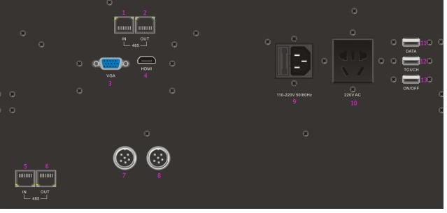
Function Introduction of Back Panel

No. | Name | Description
1 | 485 network port input of display central control | Used for 485 network input port of central control for display lifting and lowering
2 | 485 network output of display central control | Used for 485 network output port of central control for display lifting and lowering
3 | VGA port of main display | Used for VGA video signal input port of main display
4 | HDMI port of main display | Used for HDMI video signal input port of main display
5 | 485 network port input of central control for microphone lifting | Used for 485 network input port of central control for microphone lifting and lowering
6 | 485 network port output of central control for microphone lifting | Used for 485 network output port of central control for microphone lifting and lowering
7 | Signal input port of microphone | Used for signal input port of microphone
8 | Signal output port of microphone | Used for signal output port of microphone
9 | Power supply input port | Used for power supply input port
10 | Power supply output port | Used for power supply output port
11 | USB port for data transmission | Used for USB data transmission port
12 | USB port for touch wire | Used for touch function port
13 | USB control port for ON/OFF | Used for ON/OFF port of the host

- The panel card inserted in the back panel is for reference only.
- The product pictures are for reference only. Please refer to the real objects.

Control Code of Central Control Protocol

485 protocol control is adopted and two RJ45 network ports are configured at the bottom of device. Multiple devices are connected in series through common network cables. The connection between network cables and device protocol is shown as below:
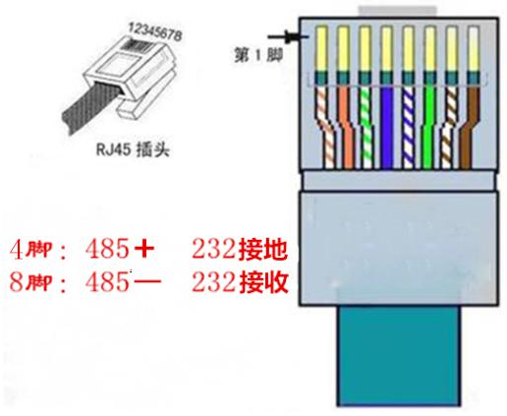
Foot 1
RJ45 plug
Foot 7: 485+ 232 grounding
Foot 8: 485 - 232 receiving
Baud rate: 2400

Parity: N

Data bit: 8

Stop bit: 1

Lift Code: FF EE EE EE DD

Lower Code: FF EE EE EE EE

Stop code: FF EE EE EE CC
- Machine Wiring Chart

s
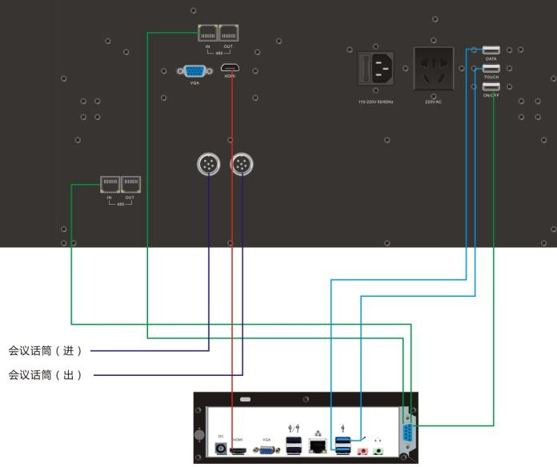
Conference microphone (IN)

Conference microphone (OUT)

- Installation Size (Product Size Drawing)

Ultra-thin 15.6-inch Lifter
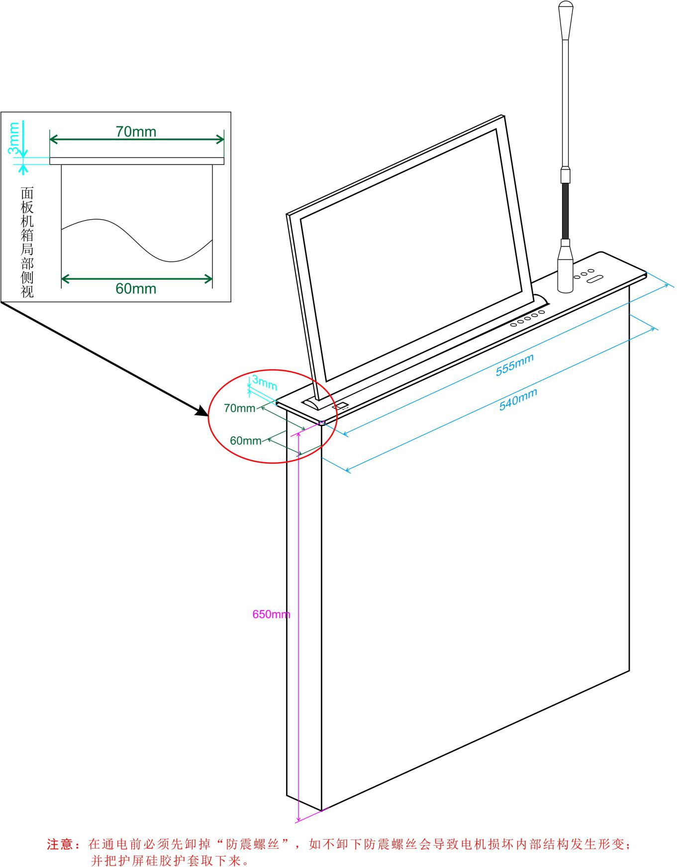
Notes: the shockproof screw must be removed before power on. Otherwise, the shockproof screw will lead motor damage and internal structure deformation. The protective silicone display cover should also be removed.
Partial side view of panel case

Ultra-thin 17.3-inch Lifter

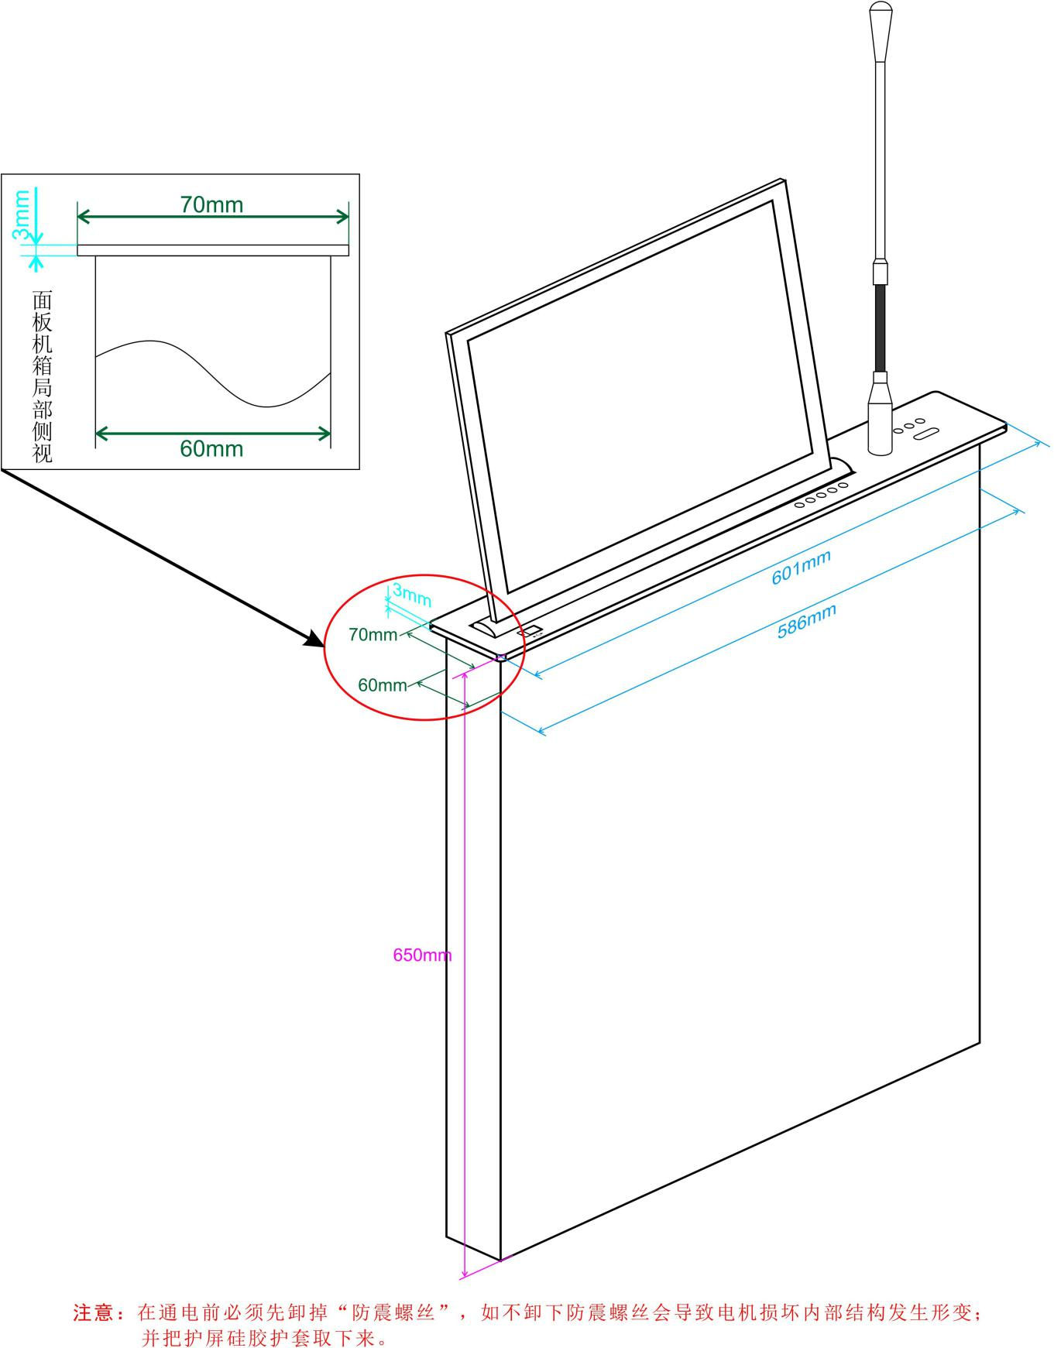
Partial side view of panel case

Notes: the shockproof screw must be removed before power on. Otherwise, the shockproof screw will lead motor damage and internal structure deformation. The protective silicone display cover should also be removed.

Installation Size (Drawing of Conference Table Hole Size)

Ultra-thin 15.6-inch Lifter
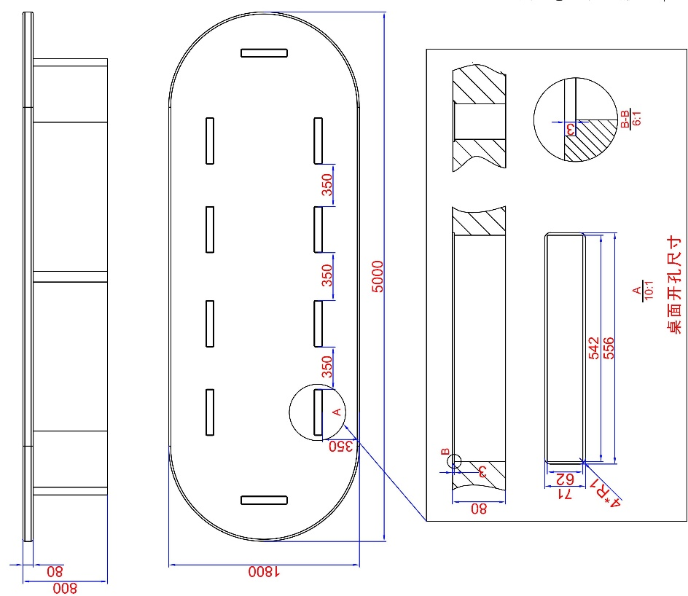
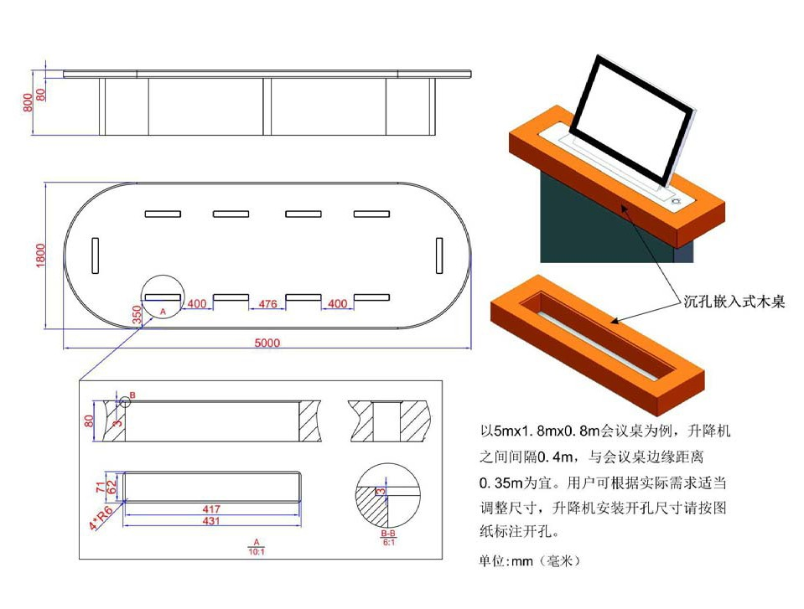
Size of table hole
Notes: the interface locates at the back panel of the machine and 100mm space must be left for wiring at least.
Embedded wooden table
with a sinking hole
Taking the 5m*1.8m*0.8m conference table as the
example, it is appropriate to space 0.35m to the lifting unit and space 0.35m to the edge of the conference table. The users can appropriately adjust the sizes according to actual requirements. Please refer to the drawing marks for the installation hole size of the lifting unit.
Unit: mm

Ultra-thin 17.3-inch Lifter
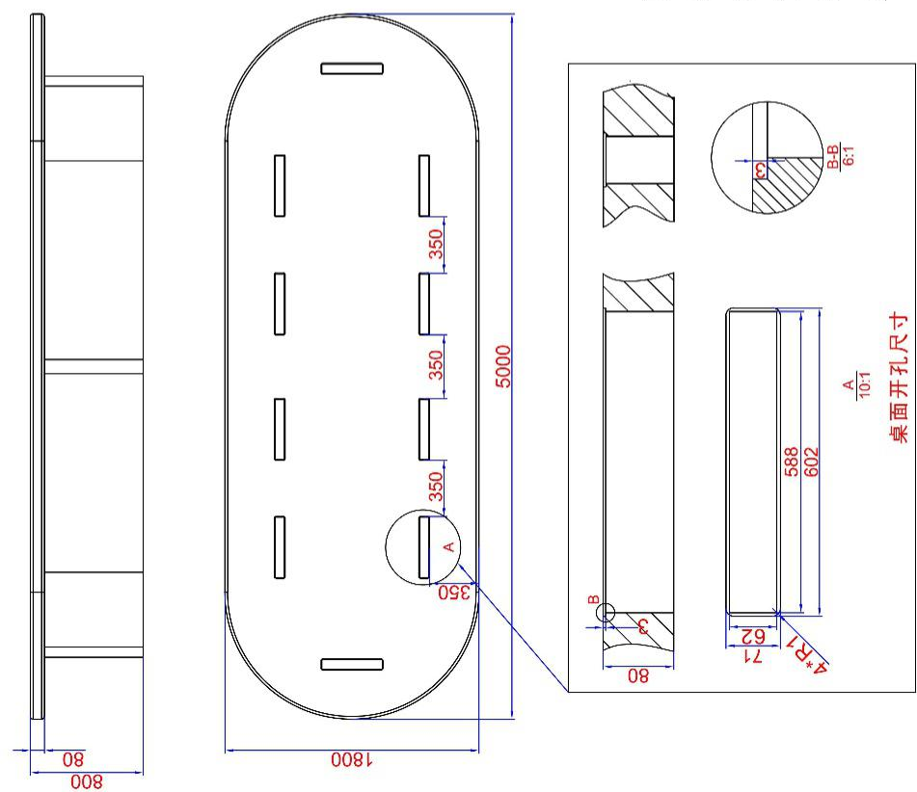
Size of table hole
Notes: the interface locates at the back panel of the machine and 100mm space must be left for wiring at least.
Embedded wooden table
with a sinking hole
Taking the 5m*1.8m*0.8m conference table as the
example, it is appropriate to space 0.35m to the lifting unit and space 0.35m to the edge of the conference table. The users can appropriately adjust the sizes according to actual requirements. Please refer to the drawing marks for the installation hole size of the lifting unit.
Unit: mm

Common Failures and Maintenance

Fault phenomenon | Reasons | Debugging
No reaction to operation of keys and the display does not lift | Unconnected power supply | Check the power supply and ensure the ON state
 | Poor contact of power supply | Check the power supply port and ensure the good contact; change another power supply input port for connection
No corresponding image output in signal switch | The signal source or terminal display is off | Check and ensure the ON state of signal source and terminal display
 | Poor contact of video signal port | Check and ensure the normal connection of corresponding video signal port
The display turns black after signal switch | The display does not support the resolution of signal source | Switch new signal sources or set as self- adaptive display resolution
Output images are disturbed | Poor contact of connecting wires between input and output devices | Correctly connect the device and ensure the good contact
 | Unqualified or damaged materials of input and output connecting wires | Change the normal-standard wire materials
 | Excessive long wires | Change the high-quality wire materials whose length is available for the system’s supporting transmission distance
Obvious static electricity in panel touch | Poor grounding of devices | Ensure the good grounding of the grounding terminal of the machine
Cannot control the machine or terminals by serial port commands | Poor contact of communication port at the control terminal | Check the communication serial port and ensure the good contact
 | Unset communication protocol | Set local or remote communication protocol according to requirements
Cannot control the machine by network | Inconsistency in network segments of the controlling device and matrix host | Change the network segment of the controlling device so that it will be consistent with that of matrix host
 | Inconsistency in network segments of matrix host and connected LAN | Change the network segment of the matrix host so that it will be consistent with that of LAN
Cannot control the machine by remoter | Dead battery | Change new batteries
 | Failed learning of remoter and machine | Learn again
Unusable | Internal damage of the host | Send to professional repair sites for repairing

After-sales Service
- If there is any abnormal situation during your use of the product, within the product warranty period, our company will take charge of free repair of any failure arising out of the quality problems of the product itself under normal use if not dismantled or repaired.
- Our company will provide one year warranty service for the product and the starting date of the warranty period is
- The date of production of the product.
- If there is no evidence available for the date above, the date of production of the product in our company’s SN code shall prevail.
- If any of the following situations occurs, the warranty service shall not be available and the fees of repairing parts shall be reasonably charged.
- Damages arising out of consumers’ inappropriate use, keeping and maintenance.
- Manual damages in appearance and parts.
- Damages arising out of configuration alternation or product modification without authorization of our company.
- Damages arising out of force majeure.
- If any of the following situations occurs, our company has the right to reject to provide repair service or to provide repair service that charges.
- The label of fragile machine body is damaged (unless authorized by our company). The label contents of the product are altered or blur, leading to incapability of recognizing.
- Damages arising out of dismantling or repair that is not authorized by our company.
- There is no sales document or the sales document is inconsistent with the model of the product requiring to be repaired.
- The products that are not produced or sold by our company.
- Please write to or call the After-sales Service Department of our company along with the following contents.
- The model and name of the product that you use
- Fault phenomenon (as specific as possible)
- The specific process of failure appearing

V0.2

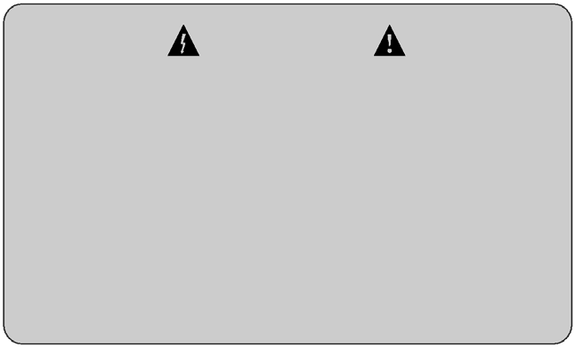
Warning
- Do not block the vent.
- Please immediately stop using the power supply wire if there is any damage.
- The product shall not be placed in the following places: where there is bad ventilation, much dust, direct sunshine, high room temperature, heat sources, vulnerability to vibration.
- The machine shall be protected from rain and damp.
- The device cannot be placed in the containers filled with liquids.
- The machine shell shall be grounded safely.
- The power supply plug shall match the socket.
- In order to avoid electric shock, please do not arbitrarily open the chassis cover. When failure occurs to the device, please turn to the supplier or manufacturer for repair service or entrust the professionals with professional certificates from professional departments to check and repair. It is forbidden for non-professionals to dismantle the machine arbitrarily in case of electric shocks that endanger the staff security.
Please understand that there will be no prior notice for any improvement in technical specifications or parameters

OWNER'S MANUAL

