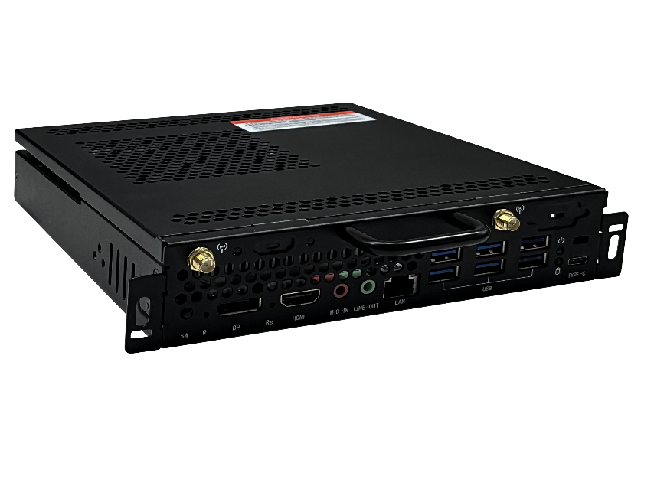
Specification parameters

CPU | Intel® Ice Lake series processor
Chipset | Intel®SOC
Memory | dual channel DDR4
Storage | 1 x M.2 SATA/NVME
Graphics | Intel® UHD Graphics
WiFi | 1 x M.2 2230 PCIe/USB
LAN | Gigabit Ethernet
Audio | Realtek ALC269
I/O Interface | 1 x USB3.1 Type-C  1 x Power LED+HDD LED  4x USB3.1 Type-A  2x USB2.0  1 x Gigabit RJ45  1 x 3.5mm sound output  1 x 3.5mm MIC  1 x HDMI2.0  1 x System recovery button  1 x DP1.2  1 x Reset/clear CMOS button  1 x Shutdown/Start up button  2 x antenna
OPS 80-pin Interface | HDMI2.0，2 x USB2.0， 1 x USB3.0，UART，Audio，Recovery，etc
Power Input | 12~19V DC Input，MAX 90W
complete machine size | 195 x 180 x 30 mm
OS | Support Windows 10/11
Environment | Operating Temp：-10℃~60℃  Operating Humidity ：10%~90%，non-condensing  Storage Temp. ：-20℃~70℃

Functional features

- Intel® OPS-C Specification
- Support Intel® Ice Lake series processor
- On board 80 pin high-speed connector
- Support dual channel DDR4 memory
- M.2 interface ，SATA/ NVMe
- M.2 interface, Wifi, Bluetooth
- Support scheduled boot, fast restore backup, PXE function

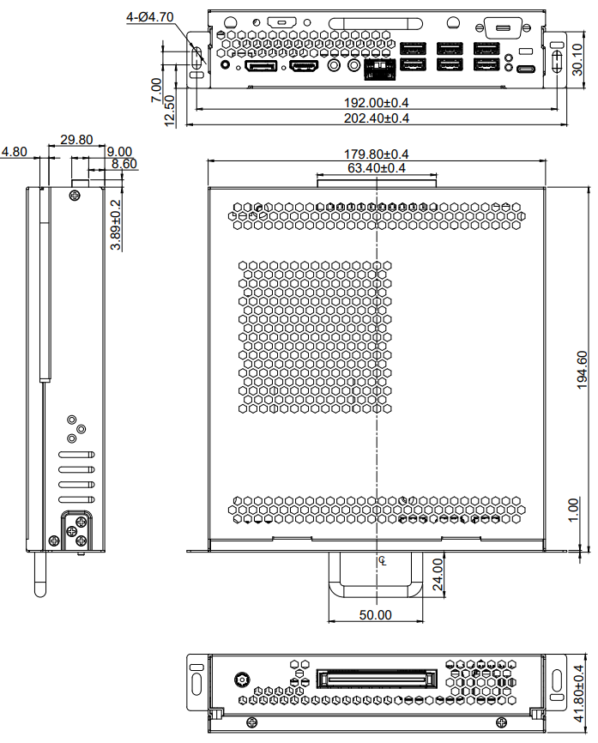

I/O Interface

