>>> Xiamen Interactive Technology Co., Ltd.d
>>> H81 I5/4460 128G Catalog <<<
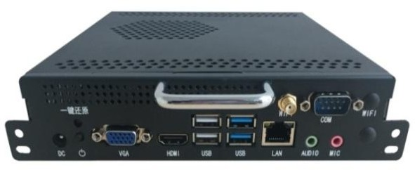  Photo |  | Main Spec:
 |  | 1.Front VGA+HDMI Port, easy to use.
 |  | 2.Build in WIFI.
 |  | 3. One key to recover OS
Processor | CPU | H81 I5
Memory | Technology | 4G
Hard Disk | SSD | 128G
I/O port | VGA*1 HDMI*1 | USB3.0*2 USB2.0*2 LAN(RJ45)*1 COM*1 AUDIO OUT*1 MIN IN*1 WIFI*2
Power | Input voltage | DC-IN 12-19V
Physical | size | 180 x 195 x 42 mm
Physical | material | Metal
Heat dissipation | Dissipation | Pure aluminum dual-ball fan for cooling and temperature control
Enviroment | Tem | 0 - 40℃
Enviroment | Humidity | 95% @40℃(Non-condensing)
Software Development Kit | OS | Windows®7.0 Windows®10
Software Development Kit | Power on automatically | Support, hardware control power-on automatic boot, motherboard jump cap mode.

